CableLabs® RI Simulator
API Validation

Media Manager



Version 0.5 | CableLabs-RISim-Media Manager

Contact Information
This document has been prepared by:
Vidiom Systems  10901 West 120th Avenue, Suite 230  Broomfield, Colorado 80021 | Phone: 303.604.0800  Web: www.vidiom.com  Email: info@vidiom.com
Intellectual Property Notice
CableLabs® Confidential and proprietary information.
Copyright
© 2008 CableLabs®. All Rights Reserved.
This document is protected by copyright. No part of this document may be reproduced in any form by any means or used in derivative works without prior written authorization of CableLabs®.
Revision History
Draft 0.1 | 06/27/2008 | Mark Millard | Initial revision.
Draft 0.2 | 06/30/2008 | Mark Millard | Replaced Vidiom notices with CableLabs notices. Added detail to mpeos_mediaChangePids() and mpeos_mediaCheckBounds()
Draft 0.3 | 06/30/2008 | Mark Millard | Tweaked mpeos_mediaDripFeedStart(), mpeos_mediaDripFeedStop(), mpeos_mediaFrequencyToTuner(), mpeos_mediaGetBounds(), and mpeos_mediaRegisterQueueForTuneEvents()
Draft 0.4 | 07/02/2008 | Mark Millard | Updated mpeos_mediaGetInputVideoSize(), mpeos_mediaGetTunerInfo() and mpeos_mediaTune()
Draft 0.5 | 07/02/2008 | Mark Millard | Updated mpeos_mediaGetAspectRatio(), mpeos_mediaGetSTC(), mpeos_mediaGetAFD(), mpeos_mediaFreeze(), mpeos_mediaResume(), mpeos_mediaStop(), mpeos_mediaSwapDecoders(), and mpeos_mediaUnregisterQueue()
Draft 0.6 | 07/07/2008 | Mark Millard | Updated sequence diagrams for Tune and Simple WatchTV scenarios. Updated mpeos_mediaDecode(), mpeos_mediaDripFeedRenderFrame(), mpeos_mediaInit() and mpeos_mediaResume()
References
External (found in Perforce, under the //Doc project):
- [OCAP] OpenCable™ Application Platform Specification; OCAP 1.0 Profile; OC-SP-OCAP1.0.1-070814.
- [CCIF] OpenCable™ CableCARD™ Interface 2.0 Specification; OC-SP-CCIF2.0-I09-070105.
- [SCTE65] SCTE Service Information Delivered Out-of-Band for Digital Cable Television; ANSI/SCTE 65 2002.
- [DRI] Digital Receiver Interface 2.0 Protocol Specification; OC-SP-DRI2.0-D02-080523.
- [BOCR] Bi-directional OpenCable Receiver; OC-SP-BOCR-D02-080523.
- Internal (found in SVN, //project/OCAP-1.0/docs/ports/VLC/design/ or //project/OCAP-1.0/docs/design):
- [VID1] OCAP Porting Guide, Vesion 1.0 (July 6, 2007); //project/OCAP-1.0/docs/VID-OCAP-PG.doc
- [VID2] The MPEOS Media APIs; //project/OCAP-1.0/docs/design/SDS/Component/Media/multiTuner_mediaApis.doc.
- [VLC1] VideoLAN VLC Media Player Analysis; TBD
- [VLC2] VLC Demux module study

Contents
Contact Information 2
Intellectual Property Notice 2
Copyright 2
Revision History 2
References 3
Contents 5
Introduction 7
Media Manager 8
2.1 Overview 8
2.2 Architecture Summary 9
2.3 API Summary 12
Media Manager API Mapping 15
3.1 mpeos_mediaBlockPresentation 15
3.2 mpeos_mediaChangePids 16
3.3 mpeos_mediaCheckBounds 19
3.4 mpeos_mediaDecode 20
3.5 mpeos_mediaDripFeedRenderFrame 25
3.6 mpeos_mediaDripFeedStart 27
3.7 mpeos_mediaDripFeedStop 28
3.8 mpeos_mediaFreeze 29
3.9 mpeos_mediaFrequencyToTuner 30
3.10 mpeos_mediaGetAFD 31
3.11 mpeos_mediaGetAspectRatio 33
3.12 mpeos_mediaGetBounds 34
3.13 mpeos_mediaGetInputVideoSize 35
3.14 mpeos_mediaGetScaling 36
3.15 mpeos_mediaGetSTC 38
3.16 mpeos_mediaGetTunerInfo 40
3.17 mpeos_mediaInit 42
3.18 mpeos_mediaRegisterQueueForTuneEvents 45
3.19 mpeos_mediaResume 46
3.20 mpeos_mediaSetBounds 47
3.21 mpeos_mediaShutdown 49
3.22 mpeos_mediaStop 50
3.23 mpeos_mediaSwapDecoders 52
3.24 mpeos_mediaTune 53
3.25 mpeos_mediaUnregisterQueue 57
Media Manager API Verification 59
4.1 Existing Unit Tests 59
4.2 New Unit Tests / Gaps 59
Media Manager Prologue 61
5.1 VLC Media Player API Assumptions 61
5.2 OCAP Requirements on VLC Media Player APIs 62
5.3 OCAP Requirements on DRI Service APIs 62
5.4 Risks 62
Media Manager UML Diagrams 64

Introduction

The following document is a summary of the porting requirements to support the Media Manager portion of the Vidiom OCAP stack on a PC platform. This document contains background information on the Media Manager to provide context for the reader as well as the following information necessary for analyzing / verifying support for Media Manager on the PC platform:
- Functionality supported / provided to the OCAP stack by the Media Manager
- Architecture for implementation of Media Manager on a Windows or Linux Platform using the VideoLAN VLC Media Player in combination with the CableLabs HE4RI simulator.
- Set of API methods exported by the Media Manager
- Media Manager API mapping to VLC Media Player APIs
- Media Manager API mapping to DRI 20 Specification [DRI]
- Media Manager API verification plan
- Open Issues
- Risks

Media Manager

  - Overview
The Media Manager provides native services to the OCAP stack for tuning. Tuning in the OCAP stack is made by using tuning parameters consisting of frequency, program number and QAM mode.
The Media Manager API provides functions for MPEG decoder control. These functions provide the mechanism for decoding and playing audio and video encoded in MPEG transport streams. The Media API also provides functions for setting and retrieving video playback and source boundaries, as well as setting volume/mute control.
The Media Manager provides a native implementation for the OCAP stack and includes the following areas of functionality:
- Tuning by FQP tuple (frequency, qam, program number)
- Validating the region, or boundary, of the screen that the video will be rendered to
- Decoding the MPEG transport stream and starting the presentation of the media
- Freezing the media while presenting a single media frame
- Identifying the association between the tuner and stream frequency
- Getting the dimension of a screen
- Getting the scaling capabilities of a decoder
- Getting tuner information and state
- Pausing the media decoding and presentation
- Resuming the media decoding and presentation
- Setting the dimension of a screen
- Shutting down the tuner(s) and decoder(s)
- Stopping the media decoding and presentation
- Processing device events generated by the tuner(s) and decoder(s)
  - Architecture Summary
This section presents a brief overview of where the Media Manager fits into the OCAP stack architecture. Figure 1 shows the Media Manager, an MPEOS component, in relation to the other components of the middleware implementation. Figure 1 also shows the context of how the Media Manager interfaces with the VLC Media Player APIs.

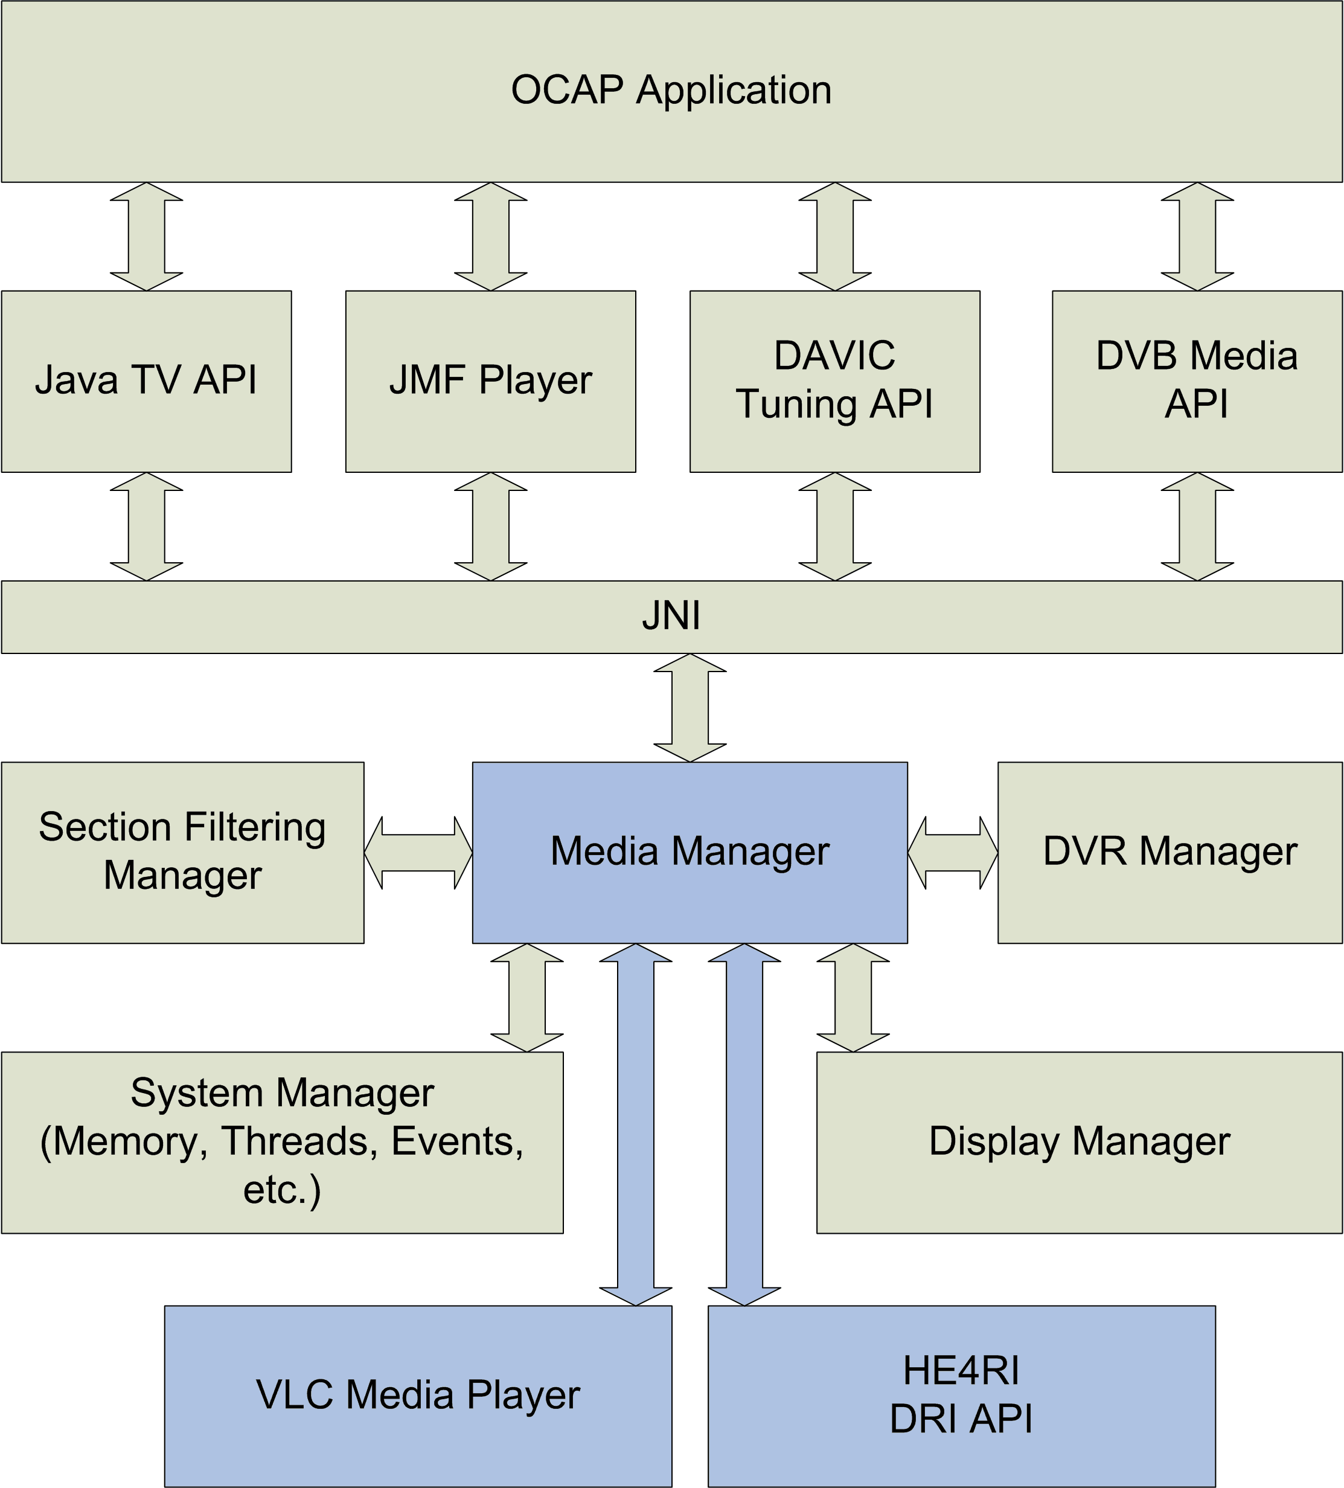
Figure 1: Media Manager Context
Figure 1 also identifies an interface between the Media Manager and the CableLabs Head-end For Reference Implementation (HE4RI) simulator.

VLC Media Player API
The VLC Media Player API consists of multiple APIs, based on core APIs comprised of seven modules. These seven modules are the Playlist, LibVLC, Interface, VLC, Input (Entrée), Video output and Audio ouput components. The MPEOS Media Manager has dependencies on the Playlist, LibVLC, Video Output and Audio output modules.
There is an OCAP implementation requirement that the stack engine should be able to run as a background process. This implies that the VLC Media Player API and DRI2.0 interface must be separable from any user interface shell; that is, they don’t require a user interface, or GUI, to be actively running.
Headend For Reference Implementation (HE4RI)
The HE4RI is a simulator of the Digital Reciever Interface 2.0 (DRI) specification. It is used to deliver cable plant data normally provided by a headend. This data includes video, audio, data, applications and signaling (i.e. AIT, XAIT, …).
Media Manager
The Media Manager is a MPEOS component that provides native services to the OCAP stack for tuning and audio/video presentation (decoding). It has a direct interface into the VLC Media Player APIs as well as the HE4RI [DRI].
The Media Manager provides services to the following MPEOS components:
- DVR Manager
- VBI Manager
- Section Filtering Manager
The Media Manager is a client of the System and Display Manager components.
System Manager
The System Manager is a collection of MPEOS APIs used to abstract functionality normally provided by the underlying operating system. The CableLabs RI Simulator project will target the Microsoft WindowsXP and Vista platforms as well as the Linux operating system. Functionality provided by the System Manager include memory management wrappers, threads and thread synchronization, event queue dispatching, timers and debug management.
Display Manager
The Display Manager is a MPEOS component that provides the OCAP stack the ability to determine a system’s graphical and video display capabilities, control the configuration of the video and graphics compositing, and render graphics.
The Media Manager makes calls into the Display Manager for handling video bounds requests.
Section Filtering Manager
The Section Filtering Manager is a MPEOS component that provides MPEG-2 transport section data to the upper layers of the stack. This includes Service Information in the way of PATs, PMTs, VCTs, etc. The upper layers, MPE, provides parsers for data such as SITP, data sections that are used in identifying data packets existing within an Objet Carousel, and information needed by the API in org.davic.mpeg.sections as explained in DAVIC 1.4.1.
The Media Manager interfaces with the Section Filtering Manager, providing tuner state information as well as PID registration and management.
DVR Manager
The DVR Manager is a MPEOS component that provides native support to implement the Open Cable Application Platform (OCAP) DVR package as well as DVR specific Java Media Framework (JMF) player controls.
The Media Manager provides services for direct access to the VLC Player Player APIs (e.g. XXX, …). The DVR Manager also provides the Media Manager with state information concerning recording of “live TV”.
VBI Manager
The VBI (Vertical Blanking Interval) Manager provides a way to extract VBI data from analog scan lines or MPEG digital video. This data consists of Closed Caption (CC) data, eXtended Data Service (XDS) packets (program information, time codes, etc.), teletext, and datacast information such as URLs and ATVEF triggers.
The Media Manager provides services to the VBI Manager. VBI sessions are tied to active media decode sessions. Hence the VBI Manager interacts with the Media Manager to check the validity of the session handle passed in.
JNI
The intermediate JNI layer is the interface between the MPE/MPEOS implementation written in C/C++ and the upper layers of the stack written in Java. It is used to translate calls from the Java layer into C /C++ and vice versa.
Java TV API
The Media Manager provides functionality to the MPE Java layer implementation of the OCAP APIs. This Media Manager API is exposed via the JNI layer. The javax.tv packages are implemented, albeit indirectly, on top of the Media Manager API.
JMF Player
OCAP employs a player based on the Java Media Framework. The JMF Player is responsible for the video presentation and control of a live broadcast stream as well as playback of a DVR recorded session. The implementation of the JMF player and javax.media packages use the Media Manager API exposed though the JNI layer. Specifically it uses the Media Manager for video decoding and video window manipulation such as scaling.
DAVIC Tuning API
OCAP requires a subset of the DAVIC 1.4.1, Part 9 packages. The implementation of the org.davic packages directly use the Media Manager API for tuning and transport stream control.
DVB Media API
The org.dvb.media API provides extensions to the Java Media Framework. This API includes extensions for Active Format Descriptors, video-drip feeds and control over video format and presentation. The implementation of the DVB Media API makes direct use of the Media Manager API.

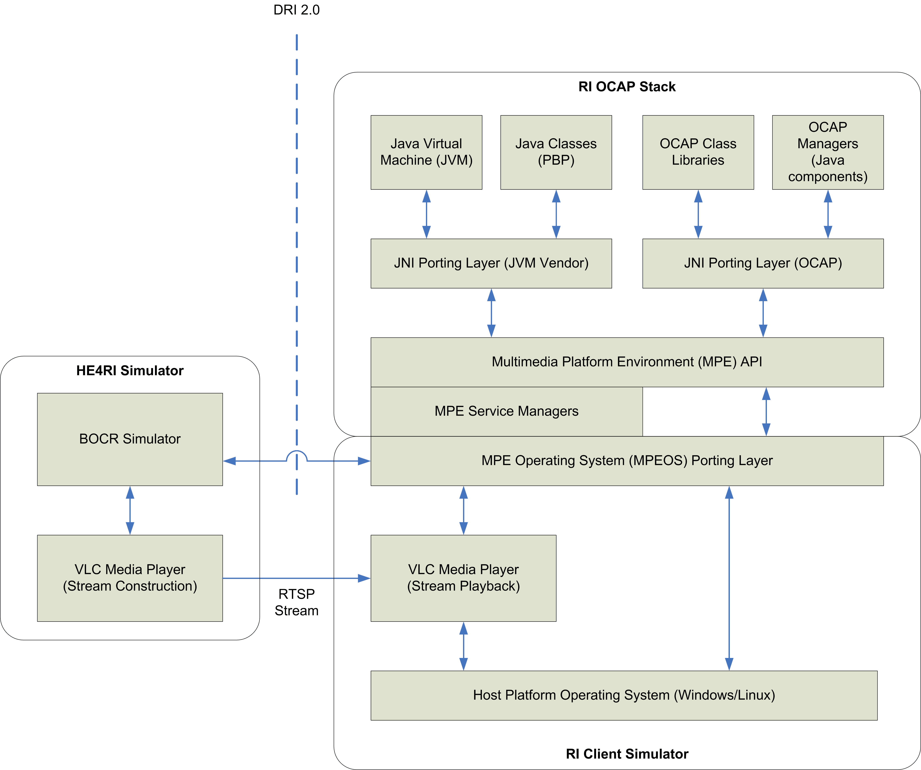
Figure 2: Reference Implementation Simulator Context

Figure 2 identifies the relationship between the RI OCAP Stack, the MPEOS porting interface to the VLC Media Player platform and the Headend for RI (HE4RI) simulator.

<Complete during implementation phase>
<Include in this description how the manager is to be implemented on the VLC Media Player platform>
<Include in this description how the manager interfaces with the HE4RI simulator using the DRI protocol>
  - API Summary
This section lists the API methods that the Media Manager exposes to the Java portion of the OCAP stack. This is the largest possible set of APIs that can possibly be mapped to corresponding VLC Media Player or HE4RI APIs. Not every method listed will necessarily require VLC Media Player or HE4RI support.
The Simulator API Mapping column lists one of the following:
- A specific VLC or HE4RI API that exists which provides the needed support
- Not needed – implying that the method can be implemented without VLC or HE4RI support
- No mapping – implying that the method requires new VLC or HE4RI API support that does not yet exist

Media Manager API | Simulator API Mapping | New Simulator API Support
mpeos_mediaBlockPresentation | No mapping | XXX – call out VLC Media Player API
mpeos_mediaChangePids | DRI MUX Service API (see Section 3.2) | None needed
mpeos_mediaCheckBounds | Not needed | None needed
mpeos_mediaDecode | Multiple VLC Media Player and DRI Service API (see Section 3.4) | Multiple VLC Media Player interfaces (see Section 3.4 for itemized list)
mpeos_mediaDripFeedRenderFrame | XXXImageFactory and XXXVideoSurface API (see Section 3.5) | None needed
mpeos_mediaDripFeedStart | Not needed | None needed
mpeos_mediaDripFeedStop | Not needed | None needed
mpeos_mediaFreeze | VLC Media Player API (see Section 3.8) | XXX – call out VLC Media Player API
mpeos_mediaFrequencyToTuner | Not needed | None needed
mpeos_mediaGetAFD | No mapping | XXX – the Active Frame Description will need to be extracted from the TS flowing across the DRI RTP Streaming interface. The VLC Media Player will be responsible for this
mpeos_mediaGetAspectRatio | VLC Media Player API (See Section 3.11) | XXX – call out VLC Media Player API
mpeos_mediaGetBounds | Not needed | None needed
mpeos_mediaGetInputVideoSize | VLC Media Player API (See Section 3.13) | None needed
mpeos_mediaGetScaling | Not needed | None needed
mpeos_mediaGetSTC | DRI MUX Service API (see Section 3.15) | XXX – the STC value will need to be extracted from the TS flowing across the DRI RTP Streaming interface. The VLC Media Player will be responsible for this
mpeos_mediaGetTunerInfo | Not Needed | None needed
mpeos_mediaInit | DRI Service API and VLC Media Player API (see Section 3.17) | XXX – call out DRI Service and VLC Media Player API
mpeos_mediaRegisterQueueForTuneEvents | Not needed | None needed
mpeos_mediaResume | VLC Media Player API (See Section 3.19) | XXX – call out VLC Media Player API
mpeos_mediaSetBounds | IiTvVideoSurface::SetVideo | None needed
mpeos_mediaShutdown | Not needed | None needed
mpeos_mediaStop | VLC Media Player and DRI Tuner Service API (See Section 3.23) | XXX – call out VLC Media Player API. Supplementary HE4RI DRI Service Tuner:Reset() action
mpeos_mediaswapDecoders | No mapping | The VLC Media Player supports multiple decoder playback through multiple instantiations of the player.
mpeos_mediaTune | DRI Tuner Service API (see Section 3.24) | None needed
mpeos_mediaUnregisterQueue | Not needed | None needed

Media Manager API Mapping
3 IR Manager Command Details
This section describes the methods exposed by the Media Manager and how they map to corresponding support in the VLC Media Player and/or HE4RI. Some methods do not require VLC or HE4RI support, some methods rely on existing VLC or HE4RI support, and others will require new VLC and/or HE4RI support to implement as summarized in the table from section API Summary.
  - mpeos_mediaBlockPresentation
The mpeos_mediaBlockPresentation() function blocks/unblocks the presentation of a decode session. Blocking a decode session is accomplished by muting audio and displaying a black video area. The decode session continues to process the stream as expected, however, the audio is not emitted and the video is not displayed.

Syntax
The mpeos_mediaBlockPresentation() function has the following syntax:
mpe_Error mpeos_mediaBlockPresentation(
mpe_MediaDecodeSession session,
mpe_Bool block );

Simulator API Mapping
There is no corresponding DRI API for this routine. Once the SetTuner() action is called on the DRI Tuner service, the MPEG transport stream will begin to flow via the RTP streaming interface.
The VLC Media Player API will need to be extended to support this playback mode. XXX – describe the module interface here.
The sequence to block playback is:
- Call XXX to block playback.
- The VLC Media Player API will generate a XXX event upon muting playback. The MPEOS API will translate this change in state to an MPE_PRESENTATION_BLOCKED event.

Simulator API Syntax
The VLC Media Player interface will have the following syntax:
XXX

Parameter Mapping
Mpeos param | VLC MP param | Comments
mpe_MediaDecodeSession session | N/A | A handle to the media decode session to be block / unblocked
mpe_Bool block | N/A | Boolean indicating whether to block or unblock

Event Mapping
The following event mappings have been identified between the VLC Media Player and the MPEOS Media Manager:

Mpeos event | VLC MP event | Comments
MPE_PRESENTATION_BLOCKED | XXX | A new event that is generated by VLC and translated to an MPE event for OCAP stack consumption
  - mpeos_mediaChangePids
The mpeos_mediaChangePids() function will change the decode PIDs asynchronously, on a given decode session.

Syntax
The mpeos_mediaChangePids() function has the following syntax:
mpe_Error mpeos_mediaChangePids (
mpe_MediaDecodeSession session,
uint32_t numPids,
mpe_MediaPID * pids,
uint32_t pcrPid);

where

typedef struct {
mpe_SiElemStreamType pidType; // PID type (e.g. audio, video, cc)
uint32_t pid; // PID value
} mpe_MediaPID;

Simulator API Mapping
The DRI MUX Service API will be used to perform this functionality. The MUX service is designed to provide visibility of the PID components that are enabled on the RTP Streaming interface. The service also provides support to extend or reduce that list of PIDs,

The DRI MUX Service API will need to support PID registration for the types enumerated by mpe_SiElemStreamType. These types are

enum mpe_SiElemStreamType {
MPE_SI_ELEM_MPEG_1_VIDEO = 0x01,
MPE_SI_ELEM_MPEG_2_VIDEO = 0x02,
MPE_SI_ELEM_MPEG_1_AUDIO = 0x03,
MPE_SI_ELEM_MPEG_2_AUDIO = 0x04,
MPE_SI_ELEM_MPEG_PRIVATE_SECTION = 0x05,
MPE_SI_ELEM_MPEG_PRIVATE_DATA = 0x06,
MPE_SI_ELEM_MHEG = 0x07,
MPE_SI_ELEM_DSM_CC = 0x08,
MPE_SI_ELEM_H_222 = 0x09,
MPE_SI_ELEM_DSM_CC_MPE = 0x0A,
MPE_SI_ELEM_DSM_CC_UN = 0x0B,
MPE_SI_ELEM_DSM_CC_STREAM_DESCRIPTORS = 0x0C,
MPE_SI_ELEM_DSM_CC_SECTIONS = 0x0D,
MPE_SI_ELEM_AUXILIARY = 0x0E,
MPE_SI_ELEM_VIDEO_DCII = 0x80,
MPE_SI_ELEM_ATSC_AUDIO = 0x81,
MPE_SI_ELEM_STD_SUBTITLE = 0x82,
MPE_SI_ELEM_ISOCHRONOUS_DATA = 0x83,
MPE_SI_ELEM_ASYNCHRONOUS_DATA = 0x84
};

The SetPidList() action is used to extend or reduce the list of PIDs that are currently enabled on the RTP Streaming interface or other DRM-specific transport service. . By default, after a successful DRI Tuner::SetTuner() request, the OCAP stack will be capturing all the PIDs related to the program found in the PMT. Although any PID of a currently tuned transport stream can be added by this action, any added PID of a copy-protected program other than the one selected by Tuner::SetTuner() will be blocked by the DRM system, and DFN packets will be inserted with a descramble_status containing the value “SetupRequired”. The PIDs defined by this action are not persistent across Tuner::SetTuner() actions

The GetPidList() action is used to determine which PIDs are currently enabled on the RTP Streaming interface or other DRM-specific transport service.

Simulator API Syntax
The MUX::SetPidList() interface has the following syntax:

SetPidList( [in] PidList pids, [out] DRI2Result result );

Where PidList is a buffer with the following structure:

number_of_pids ui4
for(i=0; i<number_of_pids; i++) {
pid ui2
}

The MUX::GetPidList() interface has the following syntax:

GetPidList( [out] PidList pids, [out] AvailableFilters filters,
[out] DRI2Result result );

Where PidList is a buffer with the following structure:

number_of_pids ui4
for(i=0; i<number_of_pids; i++) {
pid ui2
}

and AvailableFilters is a 4-byte unsigned integer.

Parameter Mapping
Mpeos param | DRI MUX param | Comments
mpe_MediaDecodeSession session | N/A | A handle to the decode session to be updated
uint32_t numPids | N/A | The number of PIDs in the array
mpe_MediaPID * pids | PidList pids | The array of new PIDs to capture mapped to SetPidList() and GetPidList()
uint32_t pcrPid | N/A | The new PCR PID to capture mapped into the array used with SetPidList() and GetPidList ()
N/A | AvailableFilters filters | The number of PID filters that are currently available(unused). This value gives an indication of the number of additional PIDs that could be added. Provided by GetPidList().
mpeError return value | DRI2Result result | The result of the action mapped to an MPE/MPEOS error code.

Event Mapping
One event has been identified that is relevant to mpeos_mediaChangePids(); it is the PidListChange event generated by the DRI MUX Service. There is currently no mapping between the DRI MUX Service and the MPEOS Media Manager.

Mpeos event | DRI MUX event | Comments
N/A | EsEvent::PidListChange | Signals a change in the current MUX service PID list. This occurs when a selected program changes the PIDs of content, following the arrival of a modified PMT for the current program.
  - mpeos_mediaCheckBounds
The mpeos_mediaCheckBounds() function verifies the region, or boundary, of the display device that the video may be rendered to. This routine should check the desired source and destination bounds for the target display device against the underlying platform supported bounds. If the desired bounds are not supported, the closest supported approximation is returned via the actual rectangles.

Syntax
The mpeos_mediaCheckBounds() function has the following syntax:
mpe_Error mpeos_mediaCheckBounds(
mpe_DispDevice videoDevice,
mpe_MediaRectangle * desiredSrc,
mpe_MediaRectangle * desiredDst,
mpe_MediaRectangle * actualSrc,
mpe_MediaRectangle * acutalDst );

where

typedef struct {
float x, y; // top-left coordinate location of region
float width, height; // width and height of region
} mpe_MediaRectangle;

Simulator API Mapping
There is no corresponding VLC Media Player or DRI Service API for this routine. It will be implemented without the use of these APIs.

Simulator API Syntax
N/A

Parameter Mapping
Mpeos param | Simulator param | Comments
mpe_MediaDevice videoDevice | N/A | A pointer to a device handle
mpe_MediaRectangle *desiredSrc | N/A | Defines the origin and dimensions of the desired source region
mpe_MediaRectangle *desiredDst | N/A | Defines the origin and dimensions of the desired destination region
mpe_MediaRectangle *actualSrc | N/A | Defines the origin and dimensions of the actual source region
mpe_MediaRectangle *actualDst | N/A | Defines the origin and dimensions of the actual destination region

Event Mapping
No events have been identified that map between the VLC Media Player or DRI Service APIs and the MPEOS Media Manager.
Mpeos event | Simulator event | Comments
  - mpeos_mediaDecode
The mpeos_mediaDecode() function starts the presentation of the specified media. This routine should start presenting the media streams (audio/video) specified by the PIDs. A successful call to mpeos_mediaTune() must be made before calling mpeos_mediaDecode(). Subsequent calls to this routine that include the PIDs which are already streaming, must continue to present those streams without interruption.

Syntax
The mpeos_mediaDecode() function has the following syntax:
mpe_Error mpeos_mediaDecode(
mpe_MediaDecodeRequestParams * decodeRequest,
mpe_EventQueue queueId,
void * act,
mpe_MediaDecodeSession * session );

where

typedef struct {
uint32_t tunerId; // tuner identifier
mpe_DispDevice videoDevice; // video device handle
uint32_t numPids; // number of PIDs
mpe_MediaPID * pids; // array of PIDs
uint32_t pcrPid; // PID value for Program Clock Reference
} mpe_MediaDecodeRequestParams;

typedef struct {
mpe_SiElemStreamType pidType; // PID type (e.g. audio, video, cc)
uint32_t pid; // PID value
} mpe_MediaPID;

Simulator API Mapping
The VLC Media Player pipeline will provide the playback and control of the MPEG stream as delivered across the DRI RTP Streaming interface. The VLC pipeline consists of the following components:
- STREAM A Core component of LibVLC
- ES_OUT A Core component of LibVLC
- INPUT A Core component of LibVLC
- DEMUX A Module component
The DEMUX module is a standalone demultiplexer, reading blocks of data from any VLC STREAM (or Access) plugin. The DEMUX module extracts the appropriate elementary streams (audio, video, subtitles) and sends them to the ES_OUT component. The ES_OUT component is responsible for managing the decoders associated with the extracted elementary streams. The VLC INPUT component is used to establish and manage the DEMUX session.
Note: Care should be taken in modifying the VLC pipeline since the support of this API will most likely share a common code base with the MPEOS DVR Manager API.
The general sequence for decoding is outlined by the Simple Watch TV Sequence Diagram found in Chapter 6 of this document. The steps are:
- An ITuner is retrieved from a list of tuners that were enumerated during Media Manager initialization. The tuner retrieved must logically match the tunerId extracted from the mpe_MediaDecodeRequestParams structure passed into mpeos_mediaDecode().
- An XML fragment, TuneXML, is created providing the frequency, QAM and program number (FQP tuple) of the MPEG transport stream.
- Begin streaming the MPEG elementary stream by calling the DRI Tuner Service. The Tuner::SetTuner() action is called with the TuneXML decription created in step 2.
- When the DRI Tuner has been successfully tuned, it will generate an asynchronous event, EsEvent::SignalLock, containing the status of the stream.
- The MPEOS Media Manager must now obtain an instance of the VLC Media Player XXX interface to control the playback presentation. Using this interface, mpeos_mediaDecode() will call XXX::Play().
- The XXX will generate an event called XXX. This asynchronous event will indicate the status of step 5. If the status is XXXPlaying, then step 5 was successful.
- When the XXX event is handled, the audio/video presentation should be audible/viewable on the output device.
Assuming that the play event in step 7 indicates successful playback (i.e. XXXPlaying), then the MPE_CONTENT_PRESENTING event can be sent to the upper layers of the OCAP stack after step 7.

Simulator API Syntax
The mpeos_mediaDecode() routine requires many new APIs from the Microsoft Capture Service. In addition to the ITuner interface identified in the mpeos_mediaTune() analysis, this function requires the following interfaces:
- XXX This interface provides methods to ...

The XXX has the following methods:
XXX::Play()

The XXX::Play() method has the following syntax:
This method is used to ...

VLCRESULT Play(
);

Parameter Mapping
Mpeos param | VLC MP param | Comments
mpe_MediaDecodeRequestParams * decodeRequest | N/A | A pointer to the decode request parameters
mpe_EventQueue queueId | N/A | Identifier for queue which will contain decode events associated with this request
void * act | N/A | A pointer to an Asynchronous Completion Token for processing asynchronous events
mpe_MediaDecodeSession * session | N/A | A pointer to a new decode session

Event Mapping
Decoding events are the direct result of a request to decode specific program media streams via mpeos_mediaDecode(). These events are expected to be sent as close to the time they actually occur as possible. The following decoding events are:
MPE_ACTIVE_FORMAT_CHANGED
MPE_ACTIVE_FORMAT_CHANGED is asynchronously sent, in response to Active Format Descriptor (AFD) changes from the BOCR device, to applications while the video is being decoded. AFD describes the input video format, either letter boxed or pillar boxed (typically 4:3 for standard definition and 16:9 for high definition).
MPE_ASPECT_RATIO_CHANGED
MPE_ACTIVE_RATIO_CHANGED is sent, in response to aspect ratio changes from the BOCR device, to applications while the video is being decoded.
MPE_CONTENT_PRESENTING
MPE_CONTENT_PRESENTING is sent to applications when the decode request is successfully presenting media.
MPE_DFC_CHANGED
MPE_DFC_CHANGED is sent to the decoder queue if the implementation changes the current Decoder Format Conversion (DFC). For OCAP implementations that can control the DFC hardware, this event must be generated (i.e. it is not optional).
MPE_FAILURE_CA_DENIED
MPE_FAILURE_CA_DENIED is asynchronously sent, in response to denied conditional access failure from the BOCR device, to applications while the video is being decoded.
MPE_FAILURE_NO_DATA
MPE_FAILURE_NO_DATA is sent to the decoder queue when the request fails because data is no longer being delivered (for example, the cable transport has been unplugged).
MPE_FAILURE_UNKNOWN
MPE_FAILURE_UNKNOWN is asynchronously sent, in response to an unknown failure from the BOCR device, to applications while the video is being decoded.
MPE_STREAM_CA_DENIED
MPE_STREAM_CA_DENIED indicates a stream is not decoding because it was denied by conditional access.
MPE_STREAM_CA_UNKNOWN
MPE_STREAM_CA_UNKNOWN is asynchronously sent back to the application when a stream is not decoding because the cipher is unknown. Unlike other events, it is not passed into or generated from any function call.
MPE_STREAM_DIALOG_PAYMENT
MPE_STREAM_DIALOG_PAYMENT indicates a stream is not decoding because a payment dialog is required.
MPE_STREAM_DIALOG_RATING
MPE_STREAM DIALOG_RATING indicates a stream is not decoding because a rating dialog is required.
MPE_STREAM_DIALOG_TECHNICAL
MPE_STREAM_DIALOG_TECHNICAL indicates a stream is not decoding because a technical dialog is required.
MPE_STREAM_HW_UNAVAILABLE
MPE_STREAM_HW_UNAVAILABLE indicates a stream is not decoding because a hardware resource is unavailable (e.g. BOCR device).
MPE_STREAM_NO_DATA
MPE_STREAM_NO_DATA indicates a stream is not decoding because it is not present.
MPE_STREAM _RETURNED
MPE_STREAM_STREAM_RETURNED indicates a requested stream is no being decoded.

These MPEOS events are handled be the following VLC Media Player and DRI Service Events:

Mpeos event | VLC MP event | Comments
MPE_EVENT_SHUTDOWN |  | Shutdown notifications from the VLC Media Player and HE4RI must be translated to MPE shutdown events
MPE_ACTIVE_FORMAT_CHANGED |  | See mpeos_mediaGetAFD() discussion
MPE_ASPECT_RATIO_CHANGED |  | See mpeos_mediaGetAspectRatio() discussion
MPE_DFC_CHANGED |  | Decoder Format Conversion has changed.
MPE_FAILURE_CA_DENIED |  | The PBDA Descramble Status code of the PID (see DRI 2.0 specification) will need to be resolved.
MPE_FAILURE_NO_DATA |  | There are many more events that may cause this. They will need to be addressed as they are enumerated.
MPE_FAILURE_UNKNOWN |  | Any other decoding failures.
MPE_CONTENT_PRESENTING |  | The PBDA Descramble Status code of the PID (see DRI 2.0 specification) will need to be resolved.
MPE_STREAM_CA_DENIED |  | The PBDA Descramble Status code of the PID (see DRI 2.0 specification) will need to be resolved.
MPE_STREAM_CA_UNKNOWN |  | The PBDA Descramble Status code of the PID (see DRI 2.0 specification) will need to be resolved.
MPE_STREAM_DIALOG_PAYMENT |  | The PBDA Descramble Status code of the PID (see DRI 2.0 specification) will need to be resolved.
MPE_STREAM_DIALOG_RATING |  | The PBDA Descramble Status code of the PID (see DRI 2.0 specification) will need to be resolved.
MPE_STREAM_DIALOG_TECHNICAL |  | The PBDA Descramble Status code of the PID (see DRI 2.0 specification) will need to be resolved.
MPE_STREAM_HW_UNAVAILABLE |  | The PBDA Descramble Status code of the PID (see DRI 2.0 specification) will need to be resolved.
MPE_STREAM_NO_DATA |  | The PBDA Descramble Status code of the PID (see DRI 2.0 specification) will need to be resolved.
MPE_STREAM_RETURNED |  | The PBDA Descramble Status code of the PID (see DRI 2.0 specification) will need to be resolved.
  - mpeos_mediaDripFeedRenderFrame
The mpeos_mediaDripFeedRenderFrame() function renders a single MPEG-2 video frame in a synchronous manner. This routine should receive an I- or P-frame that does not require future frames for decoding.

Syntax
The mpeos_mediaDripFeedRenderFrame() function has the following syntax:
mpe_Error mpeos_mediaDripFeedRenderFrame(
mpe_MediaDecodeSession mediaDecodeSession,
uint8_t * buffer,
size_t length );

Simulator API Mapping
The XXX interface will be used to create a background image from a data buffer containing an MPEG2 I-frame or P-frame. The XXXImage and XXXVideoSurface interfaces can then be used to display the image on the video plane. The VLC Media Player methods used to accomplish these steps are:
- Call XXXImageFactory to create and receive an XXXImage interface
- Send an MPE_STILL_FRAME_DECODED event back to Java.
- Call XXXVideoSurface::SetImage() passing it the XXXImage interface created in the first step.

Simulator API Syntax
The following image media types are supported by the VLC Media Player:
typedef enum ImgMediaType
{
MT_IFrame = 0,
MT_WindowsBitmap = 1
} ImgMediaType;

XXXImageFactory::Create() has the following syntax.
HRESULT Create (ImgMediaType type,
BYTE* Buffer,
LONG Size,
void** pImage);

XXXVideoSurface::SetImage() has the following syntax.
HRESULT SetImage( void* pImage,
VARIANT_BOOL FollowVideo,
VARIANT_BOOL ScaleToViewport);

Parameter Mapping
Mpeos param | VLC MP param | Comments
mpe_MediaDecodeSession mediaDecodeSession | N/A | A pointer to the video-drip feed session. Use the session object to retrieve the XXXVideoSurface interface associated with the MPE video device for this drip feed.
uint8_t * buffer | BYTE *Buffer | A pointer to the byte array containing the MPEG-2 I-Frame or P-Frame. Cast this parameter as pass through to XXXBackgroundImageFactory::Create().
size_t length | LONG size | The number of bytes in buffer. Pass through to XXXBackgroundImageFactory::Create().
N/A | ImgMediaType type | Drip feed only support MPEG IFrames, use type = MT_IFrame
N/A | IUnknown **pImage | Store the XXXImage interface received from XXXImageFactory::Create() and pass it to XXXVideoSurface::SetImage().
N/A | VARIANT_BOOL FollowVideo | Set to false
N/A | VARIANT_BOOL ScaleToViewport | Set to true to allow drip feed to fill the viewport

Event Mapping
The MPEOS Media Manager generates an MPE_STILL_FRAME_DECODED event after each call to mpeos_mediaRenderFrame when the still-frame decode operation completes. For the purposes of this analysis, it is assumed that calls to XXXImageFactory::Create() are synchronous and that the decode of the MPEG1 I-frame occurs before XXXImageFactory returns. As a result, the Media Manager can send an MPE_STILL_FRAME_DECODED event after the call to XXXImageFactory::Create().

Mpeos event | IiTv event | Comments
MPE_STILL_FRAME_DECODED | N/A | Indicates a drip-frame was decoded. This will be sent by media manager after the call to IiTvBackgroundImage::Create. See Section
  - mpeos_mediaDripFeedStart
The mpeos_mediaDripFeedStart() function initializes a drip-feed session. The decode session can be used to later submit frames of data for decode and to stop the decoding.

Syntax
The mpeos_mediaDripFeedStart() function has the following syntax:
mpe_Error mpeos_mediaDripFeedStart(
mpe_MediaDripFeedRequestParams * dripFeedRequest,
mpe_EventQueue queueId,
void * act,
mpe_MediaDecodeSession * mediaDecodeSession );

The drip feed request parameters structure contains the following members:

typedef struct {
mpe_DispDevice videoDevice; // video device handle
} mpe_MediaDripFeedRequestParams;

Simulator API Mapping
There is no corresponding VLC Media Player or DRI Service API for this routine. It will be implemented without the use of these APIs. Note that as a result of calling this method, a mapping from the MPE video device to an associated VLC Media Player Surface pointer will be made. This will allow for support of video drip feeds on a given video device on ports that support multiple video devices.

Simulator API Syntax
N/A

Parameter Mapping
mpeos param | Simulator param | Comments
mpe_MediaDripFeedRequestParams * dripFeedRequest | N/A | A pointer to the video-drip feed request parameters
mpe_EventQueue queueId | N/A | Identifier for queue which will contain video-drip feed events associated with this request
void * act | N/A | A pointer to an Asynchronous Completion Token for processing asynchronous events
mpe_MediaDecodeSession * mediaDecodeSession | N/A | A pointer to the new video-drip feed session

Event Mapping
There are no MPE events generated by this method or generated as a result of calling this method.
  - mpeos_mediaDripFeedStop
The mpeos_mediaDripFeedStop() function stops a drip-feed session.

Syntax
The mpeos_mediaDripFeedStop() function has the following syntax:
mpe_Error mpeos_mediaDripFeedStop(
mpe_MediaDecodeSession * mediaDecodeSession);

Simulator API Mapping
There is no corresponding VLC Media Player or DRI Service API for this routine. It will be implemented without the use of MCE APIs.

Simulator API Syntax
N/A

Parameter Mapping
mpeos param | Simulator param | Comments
mpe_MediaDecodeSession * mediaDecodeSession | N/A | A pointer to the video-drip feed session to stop

Event Mapping
There are no MPE events generated by this method or generated as a result of calling this method.
  - mpeos_mediaFreeze
The mpeos_mediaFreeze() function freezes the media while presenting a single media frame. This routine should capture and display a frame on the device while the media stream is still being decoded.

Syntax
The mpeos_mediaFreeze() function has the following syntax:
mpe_Error mpeos_mediaFreeze( mpe_DispDevice videoDevice );

Simulator API Mapping
The VLC Media Player XXX interface will be used to pause playback. The VLC Media Player API will generate a XXX event when the pause has been successfully completed.
The sequence to pause playback is:
- Call XXX to freeze playback.
- The MCE Media Player API will generate a XXX event upon execution of the pause. Currently, the MPEOS API does not translate this change in state to an event above the JNI layer.

Simulator API Syntax
The VLC Media Player transport event state is defined as follows:
typedef enum MCTransportState
{
TransportStateInvalid,
TransportStateStopping,
TransportStatePlaying,
TransportStatePaused
};

struct MCTransportStatus
{
MCTransportState State;
float Rate;
boolean EnodOfMedia;
};

XXX::Pause() has the following syntax:
VLCRESULT Pause();

XXX has the following syntax:
VLCRESULT TransportStatusChanged(
[in] MCTransportStatus * pTransportStatus);

Parameter Mapping
mpeos param | VLC MP param | Comments
mpe_DispDevice videoDevice | N/A | A pointer to the video device handle to pause

Event Mapping
The VLC Media Player will generate the XXX event. The MPEOS API does not currently expose this event to the upper layers of the OCAP stack.

Mpeos event | VLC MP event | Comments
N/A | XXX | MPE may need to process this event so don’t exclude it from this analysis
  - mpeos_mediaFrequencyToTuner
The mpeos_mediaFrequencyToTuner() function identifies the tuner using the specified frequency. This routine should search for the specified frequency in hertz and return, through a pointer, the tuner identifier currently tuned to the specified frequency. If more than one tuner is set to the frequency, the first one found will be selected.

Syntax
The mpeos_mediaFrequencyToTuner() function has the following syntax:
mpe_Error mpeos_mediaFrequencyToTuner(
uint32_t frequency,
uint32_t * tunerId );

Simulator API Mapping
There is no corresponding VLC Media Player or DRI Service API for this routine. It will be implemented without the use of these APIs.

Simulator API Syntax
N/A

Parameter Mapping
mpeos param | Simulator param | Comments
uint32_t frequency | N/A | The frequency to search for
uint32_t * tunerId | N/A | The found tuner identifier

Event Mapping
No events have been identified that map between the VLC Media Player or DRI Service API and the MPEOS Media Manager

Mpeos event | Simulator event | Comments
  - mpeos_mediaGetAFD
The mpeos_mediaGetAFD() function gets the current AFD for the decoder. This routine should retrieve the current active format description for the decoder.

Syntax
The mpeos_mediaGetAFD() function has the following syntax:
mpe_Error mpeos_mediaGetAFD(
mpe_DispDevice decoder,
mpe_MediaActiveFormatDescription * afd );

The Active Format Descriptions supported by OCAP describe how the input video is formatted. The AFD indicates whether or not letterbox and/or pillarbox areas are present in the input video and also indicates the placement of these letterbox and pillarbox areas.

Simulator API Mapping
The AFD is optionally carried in the user data of video elementary bitstreams, after the sequence extension, GOP header, and/or picture coding extension. Support for the AFD must be provided to meet OCAP requirements outlined by org.dvb.media.VideoFormatControl.
To resolve this problem, the recommendation is to interface with the libmpeg2 library in the VLC Media Player for retrieval of AFD and AspectRatio information.

Simulator API Syntax
The AFD enumeration and parameter is a proposed addition to the VLC Media Player XXX module.
typedef enum iTvAFD
{
AFD_NOT_PRESENT = -1,
AFD_16_9_TOP = 2,
AFD_14_9_TOP = 3,
AFD_GT_16_9 = 4,
AFD_SAME = 8,
AFD_4_3 = 9,
AFD_16_9 = 10,
AFD_14_9 = 11,
AFD_4_3_SP_14_9 = 13,
AFD_16_9_SP_14_9 = 14
AFD_16_9_SP_4_3 = 15
} iTvAFD;

VLCRESULT GetFrameFormat( LONG* VideoPixelAspectWidth,
LONG* VideoPixelAspectHeight,
LONG* VideoWidth,
LONG* VideoHeight,
iTvAFD* AFD);

Parameter Mapping
mpeos param | VLC MP param | Comments
mpe_DispDevice decoder | N/A | A handle to the decoder. Use this handle to map to a VLC Media Player interface.
mpe_MediaActiveFormatDescription *afd | iTvAFD* AFD | A pointer to a variable containing the AFD enumeration value. Pass through to VLC Media Player API.

Event Mapping
OCAP requires that applications are notified about AFD changes as they occur in the video stream. This is spelled out in org.dvb.media.ActiveFormatDescriptionChangedEvent. As a result, an OCAP port requires notification from the VLC Media Player whenever the AFD changes mid stream.

Mpeos event | VLC MP event | Comments
MPE_ACTIVE_FORMAT_CHANGED | XXX | Must add a callback to VLC Media Player API to return the current AFD value.when AFD changes
  - mpeos_mediaGetAspectRatio
The mpeos_mediaGetAspectRatio() function gets the aspect ratio for the video. This routine should get the current broadcast aspect ratio for the specified decoder.

Syntax
The mpeos_mediaGetAspectRatio() function has the following syntax:
mpe_Error mpeos_mediaGetAspectRatio(
mpe_DispDevice decoder,
mpe_MediaAspectRatio * aspectRatio );

The following are the OCAP aspectRatio values which must be determined based on information return from the VLC Media Player APIs.

ASPECT_RATIO_UNKNOWN = -1,
ASPECT_RATIO_4_3 = 2,
ASPECT_RATIO_16_9 = 3,
ASPECT_RATIO_2_21_1 = 4;

Simulator API Mapping
The IiTvVideoSurface::GetFrameFormat() method will be used to retrieve aspect ratio information.

Simulator API Syntax
VLCRESULT GetFrameFormat( LONG* VideoPixelAspectWidth,
LONG* VideoPixelAspectHeight,
LONG* VideoWidth,
LONG* VideoHeight);

Parameter Mapping
mpeos param | VLC MP param | Comments
mpe_DispDevice decoder | N/A | A handle to the decoder. Use this handle to map to an VLC Media Player XXX interface.
mpe_MediaAspectRatio * aspectRatio | LONG* VideoPixelAspectWidth, LONG* VideoPixelAspectHeight, LONG* VideoWidth, LONG* VideoHeight | A pointer to a variable containing the aspect ratio enumeration value. Use the VLC Media Player values for pixel aspect size and video size to calculate the OCAP aspectRatio.

Event Mapping
OCAP requires that applications are notified about aspect ratio changes as they occur in the video stream. This is spelled out in org.dvb.media.AspectRatioChangedEvent. As a result, an OCAP port requires notification from the VLC Media Player whenever the aspect ratio changes mid stream.
Mpeos event | VLC MP event | Comments
MPE_ASPECT_RATIO_CHANGED | XXX | Use pixel aspect and video size information to calculate OCAP aspectRatio and return it to appl.
  - mpeos_mediaGetBounds
The mpeos_mediaGetBounds() function gets the display dimensions for the target display device. This routine should return the source and destination bounds for the target display device

Syntax
The mpeos_mediaGetBounds() function has the following syntax:
mpe_Error mpeos_mediaGetBounds(
mpe_DispDevice videoDevice,
mpe_MediaRectangle * srcRect,
mpe_MediaRectangle * destRect );

Simulator API Mapping
There is no corresponding VLC Media Player or DRI Service API for this routine. It will be implemented without the use of these APIs.

Simulator API Syntax
N/A

Parameter Mapping
mpeos param | Simulator param | Comments
mpe_DispDevice videoDevice | N/A | A handle to the video device
mpe_MediaRectangle * srcRect | N/A | A pointer to the origin and dimensions of the source rectangle
mpe_MediaRectangle * destRect | N/A | A pointer to the origin and dimensions of the destination rectangle

Event Mapping
No events have been identified that map between the VLC Media Player or DRI Service API and the MPEOS Media Manager

Mpeos event | Simulator event | Comments
  - mpeos_mediaGetInputVideoSize
The mpeos_mediaGetInputVideoSize() function gets the video size. This routine should get the video pixel size before setting up the scaling or clipping.

Syntax
The mpeos_mediaGetInputVideoSize() function has the following syntax:
mpe_Error mpeos_mediaGetInputVideoSize(
mpe_DispDevice videoDevice,
mpe_GfxDimensions * dim );

where

typedef struct {
int32_t width;
int32_t height;
} mpe_GfxDimensions;

Simulator API Mapping
The VLC Media Player XXX method will be used to retrieve the input video size.

Simulator API Syntax
HRESULT GetFrameFormat( LONG* VideoPixelAspectWidth,
LONG* VideoPixelAspectHeight,
LONG* VideoWidth,
LONG* VideoHeight);

Parameter Mapping
mpeos param | VLC MP param | Comments
mpe_DispDevice videoDevice | N/A | A handle to the decoder. Use this handle to map to an VLC Media Player Surface interface.
Mpe_GfxDimensions * dim | LONG* VideoWidth, LONG* VideoHeight | A pointer to a struct containing the width and height in pixels of the video before any scaling has taken place. Use the VLC Media Player width and height to fill in the dim structure with input video width and height values.

Event Mapping
There are no MPE events generated by this method or generated as a result of calling this method.
  - mpeos_mediaGetScaling
The mpeos_mediaGetScaling() function gets the scaling capabilities of the specified decoder.

Syntax
The mpeos_mediaGetScaling() function has the following syntax:
mpe_Error mpeos_mediaGetScaling(
mpe_DispDevice decoder,
mpe_MediaPositioningCapabilites * positioning,
float ** horiz,
float ** vert,
mpe_Bool * hRange,
mpe_Bool * vRange,
mpe_Bool * canClip,
mpe_Bool * supportsComponent );

The valid values for the positioning parameter are defined by OCAP as follows:

/**
* Constant representing that the video can be positioned anywhere on
* the screen, even if a part of the video is off screen as a result
* of that.
*/
POS_CAP_FULL = 0;

/**
* Constant representing that the video can be positioned anywhere
* on screen as long as all the video is on screen.
*/
POS_CAP_FULL_IF_ENTIRE_VIDEO_ON_SCREEN = 1;

/**
* Constant representing that the video can be positioned anywhere on
* the screen, even if a part of the video is off screen as a result
* of that, with the restriction that the field order is respected. This
* implies that interlaced video can be positioned on even lines only
* (when counting from 0).
*/
POS_CAP_FULL_EVEN_LINES = 3;

/**
* Constant representing that the video can be positioned anywhere
* on screen as long as all the video is on screen, with the restriction
* that the field order is respected. This implies that interlaced
* video can be positioned on even lines only (when counting from 0).
*/
POS_CAP_FULL_EVEN_LINES_IF_ENTIRE_VIDEO_ON_SCREEN = 4;

/**
* Constant representing that the video positioning capability
* cannot be expressed by another POS_CAP_* constant.
*/
POS_CAP_OTHER = -1

Simulator API Mapping
There is no corresponding VLC Media Player or DRI Service API for this routine. It will be implemented without the use of these APIs since the information can be deduced based on the capabilities of a VLC Media Player platform. The VLC Media Player supports arbitrary scaling. Scale factors are based on the minimum window size and the maximum video dimensions. The VLC Media Player supports positioning on the screen even if part of the video is off screen.

Simulator API Syntax
N/A

Parameter Mapping
mpeos param | VLC MP  param | Comments
mpe_DispDevice decoder | N/A | A handle to the decoder. This will only be used if multiple video devices are needed (i.e. PIP)
mpe_MediaPositioningCapabilities * positioning | N/A | A pointer to the variable containing the positioning enumeration value. It is expected that MCE supports POS_CAP_FULL as defined above.
float ** horiz | N/A | A pointer to an array of available horizontal scaling factors. This will be null, it is expected that the VLC Media Player supports arbitrary scaling factors.
float ** vert | N/A | A pointer to an array of available vertical scaling factors. This will be null, it is expected that the VLC Media Player supports arbitrary scaling factors.
mpe_Bool * hRange | N/A | A pointer to a variable containing the type of horizontal scaling factor. Set to true, it is expected that the VLC Media Player supports arbitrary scaling factors.
mpe_Bool * vRange | N/A | A pointer to a variable containing the type of vertical scaling factor. Set to true, it is expected that the VLC Media Player supports arbitrary scaling factors.
mpe_Bool * canClip | N/A | A pointer to a variable indicating whether the decoder supports clipping. Set to true or false based on the capability of the VLC Media Player. This will be determined based on whether or not VLC supports setting an input clipping region.
mpe_Bool * supportsComponent | N/A | A pointer to a variable indicating whether the decoder supports component based scaling. This will be set to true or false based on whether or not VLC supports PIP.

Event Mapping
There are no MPE events generated by this method or generated as a result of calling this method
  - mpeos_mediaGetSTC
This media API is required to implement OCAP scheduled stream events and DVR Media Time Tags functionality. A brief description of these features is provided below.
NPT Stream Events: A stream event is a method of triggering an event to occur at a specific time. There are two different types of stream events – immediate events and scheduled events. In scheduled events, the stream event descriptor carries timing information that specifies when the event should occur. Such stream events are initiated based on Normal Play time (NPT). The NPT is expressed in relation to STC (System Time Clock) which is calculated by dividing the PCR (Program Clock Reference) by 300, giving it a 90Khz resolution, like NPT.
Media Time Tags: This feature allows an application to synchronize content with private data, where stream events are signaled in a proprietary fashion.
The mpeos_mediaGetSTC() function retrieves the STC on a given tuner as decoded from the given program (identified by the PCR PID). The PCR PID provided may refer to a program that is currently being presented or is being recorded.

Syntax
The mpeos_mediaGetSTC() function has the following syntax:
mpe_Error mpeos_mediaGetSTC(
uint32_t tunerId,
uint32_t pcrPID,
uint64_t * out);

Simulator API Mapping
The implementation of mpeos_mediaGetSTC will most likely require support from both the VLC Media Player and DRI Service. The DRI MUX Service will be used to set-up the PCR PID using the SetPidList() action. The STC value will then need to be extracted from the TS flowing over the DRI RTP Streaming interface. This functionality will most likely be performed by the VLC Media Player.
The following proposed interface supports STC retrieval requirements. This interface would be provided by the VLC Media Player XXX module.

interface IPlayerSTCMonitor
{
VLCRESULT StartMonitor ([in] int pcr_PID);
VLCRESULT StopMonitor ();
VLCRESULT RetrieveSTC ([out] QWORD *stc_val);
VLCRESULT Advise ([in] IPlayerSTCMonitorEvents *
pSTCMonitorEvents)
VLCRESULT Unadvise ([in] IPlayerSTCMonitorEvents *
pSTCMonitorEvents);
};
interface IPlayerSTCMonitorEvents
{
VLCRESULT SessionStopped ();
VLCRESULT NotifyDiscontinuity ();
};

Simulator API Syntax
IPlayerSTCMonitor provides following methods:
1. IRPlayerSTCMonitor::StartMonitor (int pcr_PID);
Start extracting the STC value of the program identified by the given pcr PID. The caller may synchronously retrieve the STC value using the method RetrieveSTC() at any time.
2. IPlayerSTCMonitor::StopMonitor ();
Stop monitoring the STC value of the program identified by the previous call to StartMonitor ().
3. IPlayerSTCMonitor::RetrieveSTC (QWORD *stc_val);
This method should immediately return the current STC. The STC value should be extrapolated and is a 64 bit value.
4. IPlayerSTCMonitor::Advise (IPlayerSTCMonitorEvents * pSTCMonitorEvents);
Register a listener for notification of events.
5. IPlayerSTCMonitor::Unadvise (IPlayerSTCMonitorEvents * pSTCMonitorEvents);
Unregister listener.

IPlayerSTCMonitorEvents provides following methods:
1. IPlayerSTCMonitorEvents::SessionStopped (int pcr_PID);
Notifies the registered caller that the session has been terminated. This may be caused by the DRI Tuner tuning away from the currently tuned transport stream or via an explicit call to StopMonitor() method.
2. IPlayerSTCMonitorEvents::NotifyDiscontinuity ();
Notifies caller of discontinuities found in STC. Specific use case is yet to be identified

Parameter Mapping
mpeos param | VLC MP param | Comments
uint32_t tunerId | N/A | The tunerId is a logical mapping to an DRI Tuner interface which is retrieved from the list of recorders that were enumerated during Media Manager initialization.
uint32_t pcrPID | int pcr_PID | The PCR PID value of the program we’re interested in
uint64_t out | QWORD *stc_val | A pointer to a location where the STC value is copied to.

Event Mapping
No events have been identified that map between the VLC Media Player or DRI Service API and the MPEOS Media Manager

Mpeos event | VLC MP event | Comments
  - mpeos_mediaGetTunerInfo
The mpeos_mediaGetTunerInfo() function gets the current tuner information. This routine should return the current tuning parameters for the target tuner.

Syntax
The mpeos_mediaGetTunerInfo() function has the following syntax:
mpe_Error mpeos_mediaGetTunerInfo(
uint32_t tunerId,
mpe_MediaTuneParams * tunerParams );

where

typedef struct {
mpe_MediaTuneType tuneType; // Type of tuning
uint32_t frequency; // Frequency
uint32_t programNumber; // Program number
mpe_SiModulationMode qamMode; // QAM level
} mpe_MediaTuneParams;

Simulator API Mapping
There is no corresponding VLC Media Player or DRI Service API for this routine. It will be implemented without the use of these APIs since the information can be managed internally to the MPEOS Media Manager implementation.

Simulator API Syntax
N/A

Parameter Mapping
mpeos param | Simulator param | Comments
uint32_t tunerId | N/A | The tuner identifier
mpe_MediaTunerParams * tunerParams | N/A | A pointer to the tuner information

Event Mapping
No events have been identified that map between the VLC Media Player or DRI Service API and the MPEOS Media Manager.

Mpeos event | Simulator event | Comments
  - mpeos_mediaInit
The mpeos_mediaInit() function initializes the Media API. This routine should perform platform specific initialization support for the Media API.

Syntax
The mpeos_mediaInit() function has the following syntax:
mpe_Error mpeos_mediaInit( void );

Simulator API Mapping
The BOCR is a multi-tuner device, with two tuners as a minimum complement. The UPnP BOCR advertisement contains a root device corresponding to the BOCR, with child devices that are complete DRI implementations for each physical tuner. That means there is a Tuner service, FCD service, OPA service, GNVPS service, etc., corresponding to each physical tuner.
These “virtual” BOCRs are normally “owned” by securely binding an OCAP stack to one using the OPA service. The HE4RI is dispending with the “secure” part of that contract, but retaining the binding. The initialization phase will need to call the OPA binding operations to make the tuner behave properly. (The DRI specification has “unbound” modes, but they are UDCP compatible and will not be used here.)
Note that there is no “release” action. Someone else, who does not bother to verify that the OCAP stack “BOCR” is busy, can also do a bind. This will break the connection. The HE4RI implementation provides a release utility, however, it will retain the “preemptive” bind since a crash or network partition could leave a BOCR inaccessible.
During initialization of the MPEOS Media Manager API, a handle to the He4RI DRI interface will be acquired to initiate one or more BOCR sessions. The XXX interface can then be used to enumerate information about each of the tuners available to the system.
The XXX interface is used to provide the information about a specific tuner and to reserve the interface for use by the OCAP stack. Once ownership of a specific tuner is gained, the XXX interface can be used to acquire an instance of an ITuner, which is the key interface that will be used for the actual functional interactions with each BOCR tuner device.
It is assumed that there will be a one-to-one association between the MPEOS tuner resources and a tuner exposed through the XXX interface. The OCAP implementation will enumerate through the HE4RI/BOCR tuners and statically assign an association to a MPEOS tuner resource based on the order of the enumeration.
Note that this initialization sequence may be done by the OCAP Stack initialization phase instead of this utility. In that case, this routine will validate that instances of ITuner are still owned by the OCAP stack and available for tuning.
XXX – What needs to be done to initialize the VLC Media Player?
The sequence for initialization of the Media Manager is as follows:
- Obtain an instance of the DRI XXX. This will most likely be done through the Mono CLR/CLI interface XXX().
- Enumerate through the recorders by calling XXX::EnumTunerInfo(). Each enumerated recorder correlates to an ITunerInfo instance.
- Acquire permanent ownership of the tuners by calling ITunerInfo::AcquireOwnership(). The acquired tuners will be cached in the Media Manager for later use by the MPEOS Media Manager APIs as well as other MPEOS clients (i.e. DVR Manager, Section Filtering Manager, VBI Manager, …);

Simulator API Syntax
The ITunerMgr has the following methods:
ITunerMgr::EnumTunerInfo()

The ITunerrMgr::EnumTunerInfo() method has the following syntax:
This method returns an enumerator for tuner information objects.

HRESULT EnumTunerInfo (
[out] IEnumTunerInfo ** ppEnum );

The ITunerMgrEvents has the following methods:
ITunerMgrEvents::TunerArrived()
ITunerMgrEvents::TunerDeparted()

The ITunerMgrEvents:: TunerArrived () method has the following syntax:
This event informs the ITunerMgr client that a new tuner has been created.

HRESULT TunerArrived (
[out] GUID * pTunerId );

The ITunerMgrEvents:: TunerDeparted () method has the following syntax:
This event informs the ITunerMgr client that a tuner has been removed.

HRESULT TunerDeparted (
[out] GUID * pTunerId );

The ITunerInfo has the following methods:
ITunerInfo::GetTunerId()
ITunerInfo::GetOwnerInfo()
ITunerInfo::AcquireOwnership()

The ITunerInfo::GetTunerId() method has the following syntax:
This method returns the id of the tuner. The id of a tuner is non-variant and will persist through system resets.

HRESULT GetTunerId (
[out] GUID * pTunerId );

The ITunerInfo::GetOwnerInfo() method has the following syntax:
This method returns the moniker to the ITunerOwner of the tuner.

HRESULT GetOwnerInfo (
[out] IMoniker ** ppIOwner );

The ITunerInfo::AcquireOwnership() method has the following syntax:
This method is used to acquire ownership of the tuner.

HRESULT AcquireOwnership (
[in] IMoniker * pOwner,
[out] ITuner ** ppTuner );

The ITunerInfoEvents has the following methods:
ITunerInfo::TunerStateChanged()

The ITunerInfoEvents::TunerStateChanged() method has the following syntax:
This event is used to notify clients that the state of the tuner changed.

HRESULT TunerStateChanged (
[in] TunerState NewState );

where TunerState is defined as

typedef [v1_enum] enum TunerState
{
RecorderState_Disconnected, // No connection to a tuner
RecorderState_Initializing, // Initializing by not ready for use
RecorderState_InUse_Exclusive, // Already has a high-priority owner
RecorderState InUse_Streaming, // Already owned and streaming
RecorderState_InUse_Background, // Already owned and in background
RecorderState_Idle_Ready // Available, un-owned recorder
}

Parameter Mapping
There is no direct correlation between the parameters for the MPEOS Media Manager API and the MCE Capture API. For completeness, the following table identifies the parameters expected by the MCE API.

mpeos param | DRI Service param | Comments
N/A | IEnumTunerInfo ** ppEnum | Enumerator that will enumerate all the current tuners in the system (ITunerMgr::EnumTunerInfo())
N/A | GUID * pTunerId | The identifier of the tuner. (ITunerMgrEvents.TunerArrived(), ITunerMgrEvents.TunerDeparted() and ITunerInfo::GetTunerId())
N/A | IMoniker * pOwner | The moniker of the requesting owner. (ITunerInfo::AcquireOwnership())
N/A | ITuner ** ppITuner | The interface to a tuner. (ITunerInfo::AcquireOwnership())
N/A | TunerState NewState | The new state of the tuner. (ITunerInfoEvents::TunerStateChanged())

Event Mapping
No events have been identified that map between the VLC Media Player or DRI Service API and the MPEOS Media Manager.

Mpeos event | IiTv event | Comments
  - mpeos_mediaRegisterQueueForTuneEvents
The mpeos_mediaRegisterQueueForTuneEvents() function registers an event queue. This routine should register an MPE event queue for reception of all tuner and decoder based events

Syntax
The mpeos_mediaRegisterQueueForTuneEvents() function has the following syntax:
mpe_Error mpeos_mediaRegisterQueueForTuneEvents(
mpe_EventQueue queueId );

Simulator API Mapping
There is no corresponding VLC Media Player or DRI Service API for this routine. It will be implemented without the use of these APIs.

Simulator API Syntax
N/A

Parameter Mapping
mpeos param | Simulator param | Comments
mpe_EventQueue queueId | N/A | An additional queue that receives decode and tune events that result from any mpeos_mediaDecode() or mpeos_mediaTune() calls

Event Mapping
No events have been identified that map between VLC Media Player or DRI Service APIs and the MPEOS Media Manager.

Mpeos event | Simulator event | Comments
  - mpeos_mediaResume
The mpeos_mediaResume() function resumes the media decoding. This routine should remove the frozen frame from the screen and resume playing the media stream.

Syntax
The mpeos_mediaResume() function has the following syntax:
mpe_Error mpeos_mediaResume( mpe_DispDevice videoDevice );

MCE API Mapping
The XXX interface will be used to resume playback. The VLC Media Player API will generate a XXX event when playback has resumed.
The sequence to resume playback is:
- Call XXX::Play() to restart playback.
- The VLC Media Player API will generate a XXX event upon resuming playback. Currently, the MPEOS API does not translate this change in state to an event above the JNI layer.

Simulator API Syntax
The VLC Media Player transport event state is defined as follows:
typedef enum MCTransportState
{
TransportStateInvalid,
TransportStateStopping,
TransportStatePlaying,
TransportStatePaused
};

struct MCTransportStatus
{
MCTransportState State;
float Rate;
boolean EndOfMedia;
};

XXX::Play() has the following syntax:
HRESULT Play();

XXXPlayerTransportEvents::TransportStatusChanged() has the following syntax:
HRESULT TransportStatusChanged(
[in] MCTransportStatus * pTransportStatus);

Parameter Mapping
mpeos param | VLC MP param | Comments
mpe_DispDevice videoDevice | N/A | A handle to the video device

Event Mapping
The VLC Media Player will generate the TransportStatusChanged event. The MPEOS API does not currently expose this event to the upper layers of the OCAP stack.

Mpeos event | VLC MP event | Comments
N/A | TransportStatusChanged with state TransportStatePlaying | MPE may need to process this event so don’t exclude it from this analysis
  - mpeos_mediaSetBounds
The mpeos_mediaSetBounds() function sets the extent, or bounds, of a display device. This routine should set the source and destination bounds for the target display device.

Syntax
The mpeos_mediaSetBounds() function has the following syntax:
mpe_Error mpeos_mediaSetBounds(
mpe_Dispdevice videoDevice,
mpe_MediaRectangle * srcRect,
mpe_MediaRectangle * destRect );

MCE API Mapping
The MCE Player API currently provides IiTvVideoSurface.SetVideo() to associate a video stream with a video surface. Unfortunately, this routine only supports setting the destination extent boundary. OCAP requires that an application also be able to establish the sub-region of the source, the video stream.
To meet the OCAP requirement, the IiTvVideoSurface.SetVideo() routine should be modified to support two sub-regions, the video stream source and the video surface destination. MediaCenter will then scale the video stream source region to the video surface destination region. The caller to mpeos_mediaSetBounds() is responsible for the resulting aspect ratio of the rendered output.

MCE API Syntax
The IiTvVideoSurface::SetVideo() has the following syntax:
HRESULT SetVideo(
[in] ULONGLONG VideoStreamId,
[in] RECT VideoStreamSubRegion,
[in] RECT VideoSurfaceSubRegion );

Where RECT is defined as an (x,y) coordinate pair and a (width, height) size pair. Something like Microsoft’s RECT structure that defines the coordinates of the upper-left and lower-right corners of a rectangle will also suffice:
typedef struct _RECT
{
[in] LONG left,
[in] LONG top,
[in] LONG right,
[in] LONG bottom
} RECT;

Parameter Mapping
mpeos param | IiTv param | Comments
mpe_DispDevice videoDevice | N/A | A handle to the video device
mpe_MediaRectangle * srcRect | RECT VideoStreamSubRegion | A pointer to the origin and dimensions of a source rectangle
mpe_MediaRectangle * destRect | RECT VideoSurfaceSubRegion | A pointer to the origin and dimensions of a destination rectangle
N/A | ULONGLONG VideoStreamId | The identifier of the video stream.

Event Mapping
No events have been identified that map between MediaCenter and the MPEOS Media Manager

Mpeos event | IiTv event | Comments
  - mpeos_mediaShutdown
The mpeos_mediaShutdown() function sends shut down events to the tuner and decoder. This routine should send shutdown events to the tuner and decoder, releasing any media related resources back to the underlying operating system.

Syntax
The mpeos_mediaShutdown() function has the following syntax:
mpe_Error mpeos_mediaShutdown( void );

MCE API Mapping
The IiTvPlayerTransport interface will be used to stop playback. The MCE Player API will generate a IiTvPlayerTransportEvents::TransportStatusChanged() event when the playback has been successfully stopped.
The sequence to stop playback is:
- Call IiTvPlayerTransport::Stop() to discontinue playback.
- The MCE Player API will generate a IiTvPlayerTransportEvents::TransportStatusChanged(MCTransportState) event upon execution of the stop. The MPEOS API will translate this change in state to an MPE_EVENT_SHUTDOWN event.
- Call IRecorder.CloseMedia() to shutdown the recorder.

MCE API Syntax
The MCE Player transport event state is defined as follows:
enum MCTransportState
{
TransportStateInvalid,
TransportStateStopping,
TransportStatePlaying,
TransportStatePaused
};

struct MCTransportStatus
{
MCTransportState State;
float Rate;
boolean EnodOfMedia;
};

IiTvPlayerTransport::Stop() has the following syntax:
HRESULT Stop();

IiTvPlayerTransportEvents::TransportStatusChanged() has the following syntax:
HRESULT TransportStatusChanged(
[in] MCTransportStatus * pTransportStatus);
The IRecorder::CloseMedia() method has the following syntax:
This method stops the recorder from acquiring media.
HRESULT CloseMedia();

Parameter Mapping
mpeos param | IiTv param | Comments
N/A | MCTransportStatus * pTransportStatus | The status of the call to IiTvPlayerTransport::Stop() (IiTvPlayerTransportEvents::TransportStatusChanged())

Event Mapping
The MCE Player will generate the TransportStatusChanged event with the state TransportStateStopping set. The MPEOS API will expose this event to the upper layers of the OCAP stack as an MPE_EVENT_SHUTDOWN event.

Mpeos event | IiTv event | Comments
MPE_EVENT_SHUTDOWN | TransportStatusChanged with state TransportStateStopping
  - mpeos_mediaStop
The mpeos_mediaStop() function stops decoding and the presentation of the media.

Syntax
The mpeos_mediaStop() function has the following syntax:
mpe_Error mpeos_mediaStop( mpe_MediaDecodeSession session );

Simulator API Mapping
The VLC Media Player XXX interface will be used to stop playback. The VLC Media Player API will generate a XXX event when the playback has been successfully stopped. Once the VLC Media Player API has acknowledged that the presentation of the media has stopped, the DRI Tuner Service will be called to shutdown the RTP stream.
The sequence to stop playback is:
- Call XXX to discontinue playback.
- The VLC Media Player API will generate a XXX event upon execution of the stop. The MPEOS API will translate this change in state to an MPE_EVENT_SHUTDOWN event.
- Stop the DRI Tuner Service by calling Tuner:Reset.

Simulator API Syntax
The VLC Media Player transport event state is defined as follows:
typedef enum MCTransportState
{
TransportStateInvalid,
TransportStateStopping,
TransportStatePlaying,
TransportStatePaused
};

struct MCTransportStatus
{
MCTransportState State;
float Rate;
boolean EndOfMedia;
};

The VLC Media Player Stop() has the following syntax:
VLCRESULT Stop();

The VLC Media Player XXX has the following syntax:
VLCRESULT TransportStatusChanged(
[in] MCTransportStatus * pTransportStatus);

The DRI Tuner Service Tuner::Reset() action has the following syntax:
This method stops the DRI Tuner Service from acquiring media.
Reset( [out] dri2result Result );

Parameter Mapping
mpeos param | Simulator param | Comments
mpe_MediaDecodeSession session | N/A | A pointer to the decode session to stop
N/A | dri2result Result | The status of the DRI Tuner Service call to stop streaming media (HE4RI supplemental DRI interface action, Reset())

Event Mapping
The VLC Media Player will generate the XXX event when the media presentation has been stopped. The MPEOS API will expose this event to the upper layers of the OCAP stack as an MPE_EVENT_SHUTDOWN event.

Mpeos event | Simulator event | Comments
MPE_EVENT_SHUTDOWN | XXX
  - mpeos_mediaSwapDecoders
The mpeos_mediaSwapDecoders() function swaps the video source feeds to the two specified decoders. This routine is used to swap the video source stream feeding two specified decoders. For example, it could be used for swapping the current window and the picture-in-picture window (PIP).

Syntax
The mpeos_mediaSwapDecoders() function has the following syntax:
mpe_Error mpeos_mediaSwapDecoders(
mpe_DispDevice decoder1,
mpe_DispDevice decoder2,
mpe_Bool useAudio );

Simulator API Mapping
There is no corresponding VLC Media Player or DRI Service API for this routine. It will be implemented without the use of MCE APIs. It is possible that this API is deprecated and no longer necessary for the OCAP stack implementation.

Simulator API Syntax
N/A

Parameter Mapping
mpeos param | Simulator param | Comments
mpe_DispDevice decoder1 | N/A | A handle to one of the two decoders to swap
mpe_DispDevice decoder2 | N/A | A handle to the other decoder to swap
mpe_Bool useAudio | N/A | A flag indicating which audio to present after the swap; TRUE = decoder1’s audio should be used, else use decoder2’s audio

Event Mapping
No events have been identified that map between MediaCenter and the MPEOS Media Manager.

Mpeos event | Simulator event | Comments
  - mpeos_mediaTune
The mpeos_mediaTune() function starts the asynchronous tune operation. When tuning to an analog service, specifying the frequency alone is sufficient (QAM mode = 0, program number is not applicable).

Syntax
The mpeos_mediaTune() function has the following syntax:
mpe_Error mpeos_mediaTune(
mpe_MediaTuneRequestParams * tuneRequest,
mpe_EventQueue queueId,
void * act);

where

typedef struct {
uint32_t tunerId; // tuner identifier
uint32_t tsId; // transport stream identifier
mpe_MediaTuneParams tuneParams; // tuning parameters
} mpe_MediaTuneRequestParam;

typedef struct {
mpe_MediaTuneType tuneType; // type of tune
uint32_t frequency; // frequency
uint32_t programNumber; // program number
mpe_SiModulationMode qamMode; // QAM level
} mpe_MediaTuneParams;

Simulator API Mapping
The DRI Tuner service will be used to tune the He4RI to a particular transport steam and initiate the flow of the transport stream across the BOCR/HMS interface via RTP. Once the stream is flowing, the DRI Mux service can be used to further configure the flow of the stream by adding and removing elementary streams based on their associated PID values. This is the method that will be used for enabling/disabling alternate elementary streams for PSI (e.g. PMTs), audio and data (e.g. DSM-CC). The DRI Mux service is also the means of acquiring additional services associated with the transport stream like section filtering.

Note: under DRI 2.0 most of Conditional Access is resolved prior to the DRM, and the DRM basically receives a clear or re-encrypted stream, including the content restrictions. The CCI byte is not made available via DRI since that is only valid for current content and the DRM will always have it. In the absence of a DRM, a GNVPS query will be used to retrieve it (the CCI byte). Also, since the HE4RI emulation has neither a CableCard nor DRM, the He4RI will directly pass the TS as received from the file or network. If it is encrypted, it stays that way.

Upon completion of the tuning operations performed by the DRI Tuner Service, an event will be invoked, EsEvent::SignalLock. When this event is received, the MPE_TUNE_COMPLETE event will be sent to the upper layers of the OCAP stack.

The sequence for tuning is as follows:

- An ITuner is retrieved from a list of tuners that were enumerated during Media Manager initialization. The tuner retrieved must logically match the tunerId extracted from the mpe_MediaTuneRequestParams structure passed into mpeos_mediaTune().
- Construct the XML encoded buffer consumed by the DRI Tuner:SetTuner() action .This is done by calling ITuner:getTuneXml() using the frequency, program number and QAM contained in the mpe_MediaTuneParams structure referenced by mpe_MediaTuneRequestParams.
- Call DRI Service Tuner::SetTuner() with the XML fragment created in step 2.
- Wait for an asynchronous event from the DRI Tuner Service to determine the success or failure of step 3. This event will be EsEvent::SignalLock which will contain the status of the tune request (the signal has been locked and loaded).
- If the tune is successful, mpeos_mediaTune() will post an MPE_TUNE_COMPLETE event. If the tune was unsuccessful, the MPE_TUNE_FAIL event will be posted.

Simulator API Syntax
The DRI Tuner service has the following actions:
Tuner::SetTuner()
Tuner::GetTunerState()

The DRI Tuner service has the following events:

EsEvent::SignalLock()
GenaEvent::SignalLock() Not used

The Tuner::SetTuner() action has the following syntax:
This action is used by the HMS to request the DRI 2.0 adapter to localize a certain program and to make it available on the DRI 2.0 Streaming interface. The service does not wait for the entire channel change time, but provides a status only on the tuner availability and the completeness of the XML template. The status resulting when the tune operation has completed is provided independently via the ESEvent::SignalLock.
SetTuner(
[in] string TuneXml, [out] dri2result Result );
The Tuner::GetTunerState() action has the following syntax:
This action is used by the HMS to verify if the DRI 2.0 adapter tuner is properly set to the parameters directly or indirectly provided by the SetTuner() action. If the tuner has not locked yet, the DRI 2.0 receiver should wait until the time out, provided as input, elapsed before responding.
GetTunerState(
[in] ui4 Timeout, [out] string TunedXml,
[out] boolean SignalLockOut, [out] boolean signalPresent);

XML Fragment for DRI Tuner::SetTuner
An XML fragment will need to be generated to accommodate tuning by carrier frequency, program number, and QAM. The fragment for establishing a tuning request to be used by the Tuner::SetTuner() action is as follows:

<?xml version="1.0" encoding="utf-8"?>

<!-- presumably on the wire, this top level tune:Tuning element would
be implicitly specified and not literally present. but, having the element
in the schema helps w/ testing & validation
-->
<tune:Tuning
xmlns:tune="http://schemas.microsoft.com/2006/eHome/MediaCenter/Tuning.xsd"
xmlns:xsd="http://www.w3.org/2001/XMLSchema"
xmlns:xsi=”http://www.w3.org/2001/XMLSchema-instance”
xsi:schemaLocation="http://schemas.microsoft.com/2006/eHome/MediaCenter/Tuning.xsd
file://tuning.xsd">

<!-- Tune to Digital Cable Freqency 570MHz, QAM256, Program #4 -->
<tune:DigitalCable MinorChannel="-1" MajorChannel="-1">
<tune:Locator xsi:type="tune:DigitalCableLocatorType" Frequency="570000"
ModulationType="256QAM" InnerFECMethod="Uninitialized"
InnerFECRate="Uninitialized"
OuterFECMethod="Uninitialized" OuterFECRate="Uninitialized" SymbolRate="-1"
PhysicalChannel="39" TransportStreamID="-1" ProgramNumber="4"/>
<tune:Components xsi:type="tune:ComponentsType"/>
</tune:DigitalCable>
</tune:Tuning>

Parameter Mapping
mpeos param | Tuner Service param | Comments
mpe_MediaTuneRequestParams * tuneRequest | N/A | A pointer to the tune request parameters
mpe_EventQueue queueId | N/A | Identifier for queue which will contain tune events associated with this request
void * act | N/A | A pointer to an Asynchronous Completion Token for processing asynchronous events
N/A | string TuneXml | The XML encoded buffer identifying what to tune (Tuner::SetTuner())
N/A | dri2result Result | The result of a successful request will be SUCCESS (Tuner::SetTuner())
N/A | ui4 Timeout | The maximum amount of time in milliseconds that the DRI 2.0 adapter may block before returning (Tuner::GetTunerState())
 | string TunedXml | The XML encoded buffer describing the state of what the tuner is currently tuned to (Tuner::GetTunerState())
N/A | boolean SignalLockOut | true when a RF signal is locked, and false otherwise (Tuner::GetTunerState())
N/A | boolean SignalPresent | true when a RF signal is present, and false otherwise (Tuner::GetTunerState())

Event Mapping
The DRI Tuner Service will signal that the tuner is locked through the EsEvent::SignalLock event. When this event is received, the MPEOS will deliver the MPE_TUNE_COMPLETE event to the upper layers of the OCAP stack.

Mpeos event | Tuner Service event | Comments
MPE_EVENT_SHUTDOWN |  | Indicates no further events can be sent to the queue
MPE_TUNE_ABORT |  | Specifies either a tuning parameter change or an asynchronous failure that occurred during or after tuning
MPE_TUNE_COMPLETE | EsEvent::SignalLock where status changed indicates the signal is locked (true) | Specifies the tune is complete
MPE_TUNE_FAIL | N/A – error is returned in Tuner::SetTuner dri2result | Specifies the tune did not complete
MPE_TUNE_STARTED | N/A | Specifies a tune was requested and that request is being processed
  - mpeos_mediaUnregisterQueue
The mpeos_mediaUnregisterQueue() function unregisters an event queue. This routine should unregister an MPE event queue from receiving tuning and decoding events.

Syntax
The mpeos_mediaUnregisterQueue() function has the following syntax:
mpe_Error mpeos_mediaUnregisterQueue( mpe_EventQueue queueId );

Simulator API Mapping
There is no corresponding MCE API for this routine. It will be implemented without the use of MCE APIs.

Simulator API Syntax
N/A

Parameter Mapping
mpeos param | Simulator param | Comments
mpe_EventQueue queueId | N/A | The identifier for the queue to unregister

Event Mapping
No events have been identified that map between the VLC Media Player or DRI Service API and the MPEOS Media Manager

Mpeos event | Simulator event | Comments

Media Manager API Verification
  - Existing Unit Tests
<List existing unit tests for this manager that will be executed for validation of VLC Media Player APIs on the PC platform. Do not list APIs that only validate MPE functionality only (e.g. null parameter / invalid parameter tests that touch only MPE code) >

< Complete during implementation phase>

<Example table to be filled in by QA>
Test Name | Test Description | Expected Result
vte_test_timeClock | Verify clock is incrementing | Returns the amount of CPU time used by the current process or thread
  - New Unit Tests / Gaps
<List all new unit tests that will be needed to exercise VLC and HE4RI functionality used by this manager>

<Complete during implementation phase>
<Example table to be filled in jointly by QA and DEV>
Test Name | Test Description | Expected Result
NOT DEVELOPED | Action parameter is MPE_DFC_PROCESSING_NONE (inactive decoder format) | MPE_SUCCESS

Media Manager Prologue

  - VLC Media Player API Assumptions
The following is a list of assumptions in understanding how the IiTvBackgroundImageFactory, and IiTvVideoSurface interfaces function. The API mappings analysis above relies on these assumptions. These assumptions do not address OCAP compliance issues. They are listed in order to document implementation issues which a port to MCE would need to address. If any assumptions are in error, then the associated MPEOS implementation adjustment must be made to address the error.
- In regards to video drip feed frame decode, calls to IiTvBackgroundImageFactory::Create() are assumed to be synchronous and the decode of the MPEG1 I-frame occurs before IiTvBackgroundImageFactory returns. This is not a requirement for OCAP compliance, however, it does impact the implementation for an OCAP port in order to repaint at the correct time after a video drip frame is decoded. If synchronous decode behavior is not occurring, then the port will need an event from MCE notifying the completion of a frame decode operation triggered by IiTvBackgroundImageFactory::Create().
- It is assumed that the IiTvVideoSurface::GetFrameFormat() method returns information about the currently decoded video input frames and does NOT return information regarding the on-screen viewport.
- To support org.dvb.media.VideoPresentationControl, the OCAP port must determine the scaling capability of the platform. It is assumed that MCE supports arbitrary horizontal and vertical scaling of video and supports positioning of the video anywhere on the screen even if this places a portion of the video “off screen”. Other presentation factors like support for clipping and support for component video (PIP) must also be determined, but can be statically filled in by the port once MCE capabilities are known.
  - OCAP Requirements on VLC Media Player APIs
The following is a list of API requirements identified while performing the API mapping analysis from the MPEOS Media Manager API to the VLC Media Player APIs. The following have been identified as missing support or missing APIs needed to provide a full OCAP media implementation:
  - OCAP Requirements on DRI Service APIs
The following is a list of API requirements identified while performing the API mapping analysis from the MPEOS Media Manager API to the DRI Service APIs. The following have been identified as missing support or missing APIs needed to provide a full OCAP media implementation:
  - Risks
This section discusses the risks associated with the implementation of the Media Manager API targeting the HE4RI simulator and VLC Media Player API.

Limited API Coverage Risks
This section covers risks associated with missing APIs.
- Failure to provide separable tuning and recording features independent of Media Center activation (see Requirement 2 above)
This separation of functionality enables the following OCAP features
  - DVR scheduled recordings
  - Loading monitor and guide applications
  - XAIT/AIT acquisition
  - Application updates & refreshing guide data
  - OCAP stack updates
These features will be lost if the MCE API does not provide a mechanism to tune and/or decode without the Media Center shell being present and activated.
- Media Center provides no support for Picture-in-Picture (PIP)
The current Media Center API does not support PIP or multi-screen configurations. In fact, if this feature becomes a requirement for an MSO application deployment (e.g. a service guide), then the Media Center API and architecture will need considerable work to enable this capability.
PIP enables the viewer with the capability to view two live channels at the same time. It also allows the viewer to watch live TV while previewing a DVR recording.

Potential Performance Issues
This section covers potential performance issues.
- Software decode of I-Frames may slow playback
OCAP requires support for I-frames and P-frames in the background plane. The MediaCenter API does not directly address this feature. Although having the OCAP stack provide a software codec to accomplish this task is acceptable, it may not be practical. There may be a penalty in performance by taking this approach and there will be a licensing impact on all OCAP ports for MPEG decoding.

Media Manager UML Diagrams

Sequence Diagram 1: Simple Tune
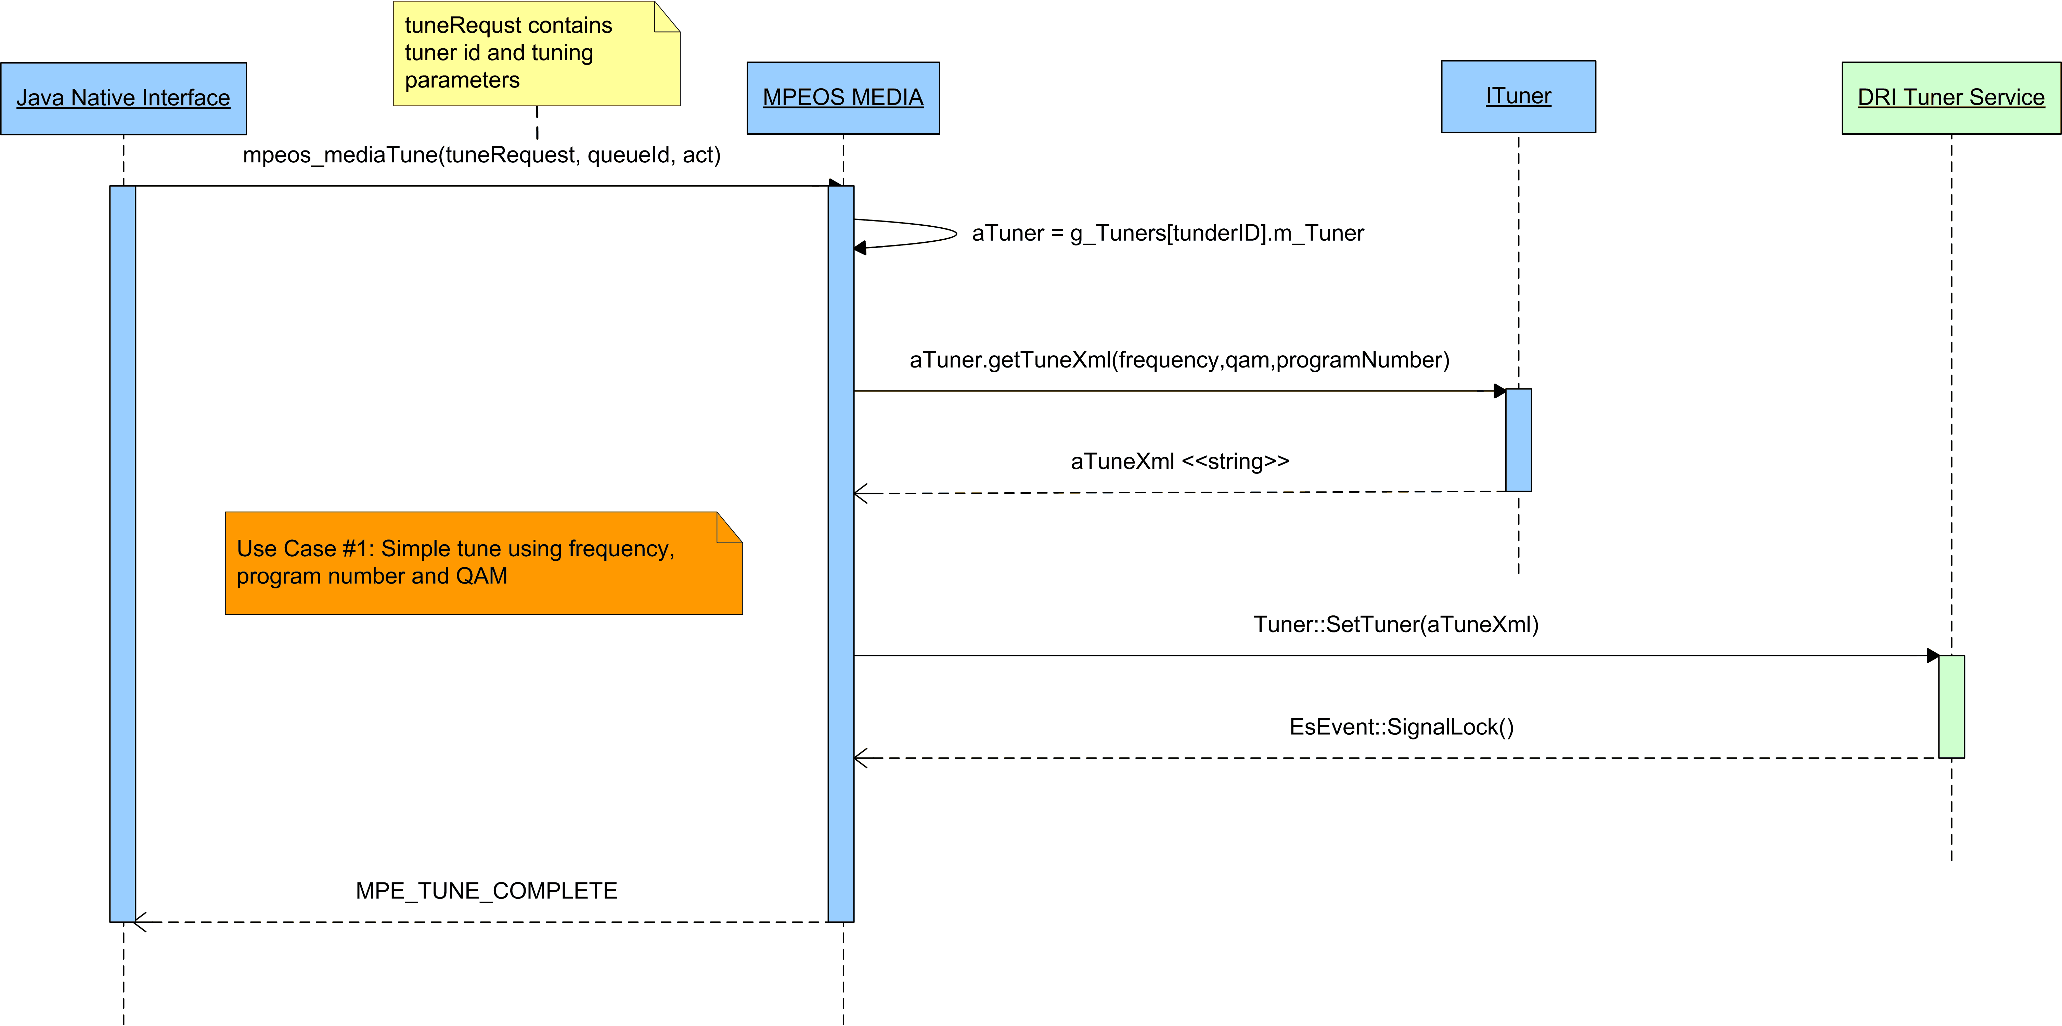

Sequence Diagram 2: Simple Watch TV
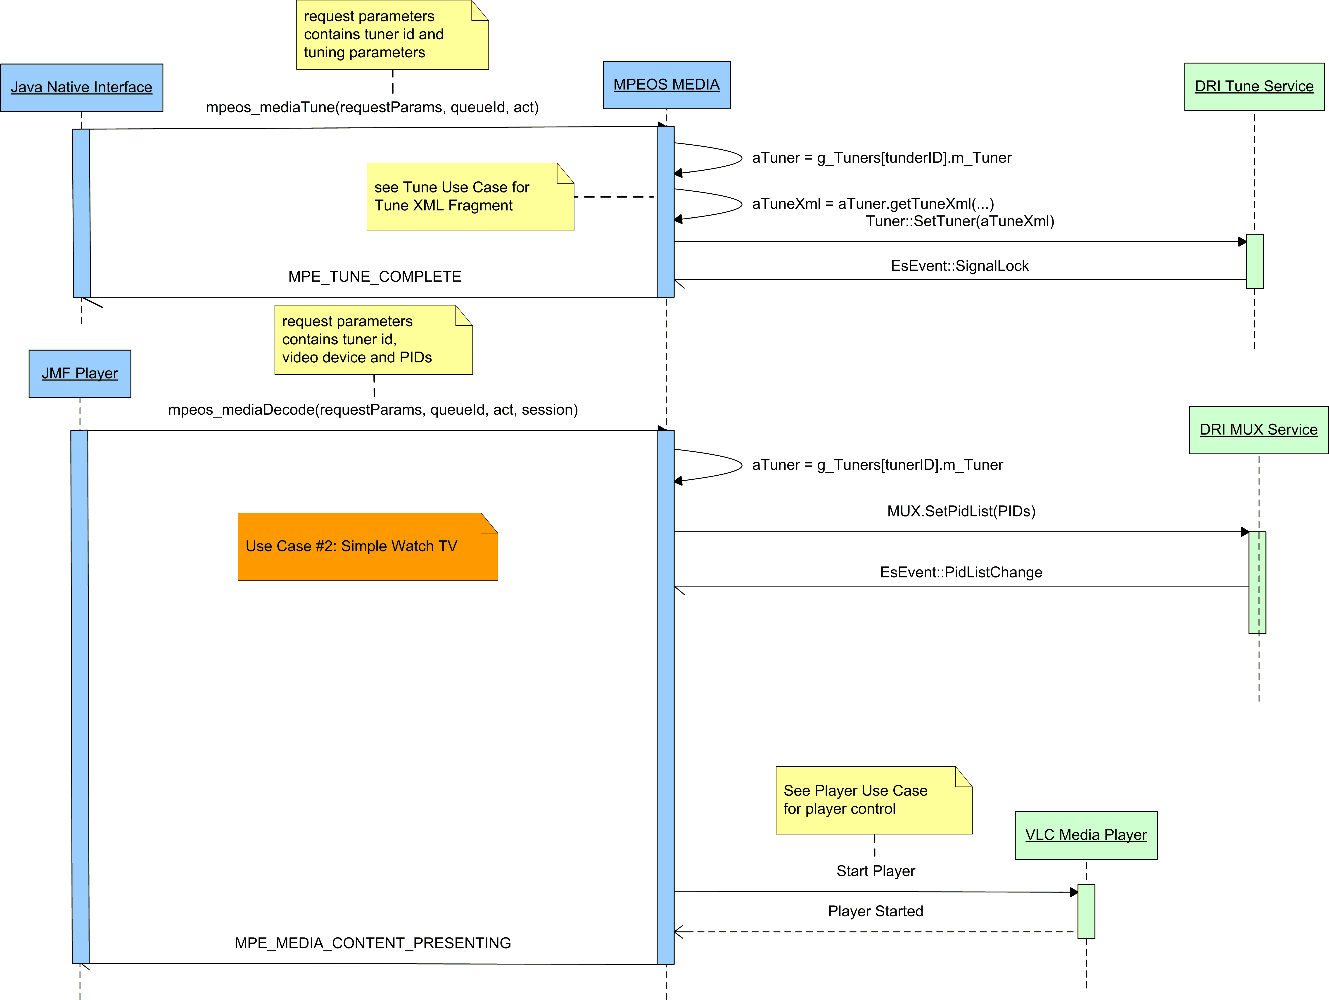

Sequence Diagram 3: Player Control
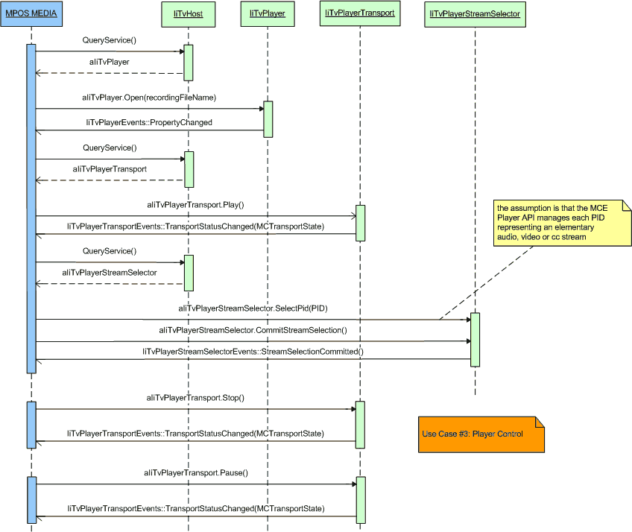

Class Diagram 1: VLC Media Player Input API

Class Diagram 2: VLC Media Player Video Output API

Class Diagram 3: VLC Media Player Audio Output API

A PC platform refers to an Intel architecture running either Microsoft Windows XP, Microsoft Vista or Linux.
The upper layers of the OCAP stack, above the JNI layer, currently support tuning by source ID using information extracted from the SI data.

